
Prepared for the Town of Coventry by UConn TAB
Student Contributor: Aaron Hinze
Summer 2024
Town of Coventry, CT
Site Reuse Assessment
28 & 30 Mason Street - Coventry, CT

Table of Contents
LIST OF FIGURES ii
LIST OF TABLES iii
ACRONYM/ABBREVIATION LIST iv
SECTION 1 - INTRODUCTION & OBJECTIVES 1
SECTION 2 - SITE INFORMATION 1
SECTION 3 - NEIGHBORHOOD CHARACTERISTICS 4
3.1 DEMOGRAPHICS 4
3.2 PUBLIC FACILITIES AND SERVICES 6
3.3 FOOD ACCESS 9
3.4 BUSINESSES 9
3.5 COMMUNITY STAKEHOLDERS 10
SECTION 4 - SUMMARY OF PLANNING STUDIES 11
SECTION 5 - SITE-SPECIFIC CONSIDERATIONS 13
5.1 ZONING REGULATIONS 13
5.2 FLOODPLAINS 15
5.3 WETLANDS 15
5.4 SOILS 16
5.5 PUBLIC DRINKING WATER SUPPLY PROTECTION (Including Service Areas) 18
5.6 NATURAL DIVERSITY DATABASE (State/Federal Listed Species & Critical Habitat) 18
5.7 COMMUNITY VULNERABILITY TO EFFECTS OF CLIMATE CHANGE 18
SECTION 6 - TRAFFIC & INFRASTRUCTURE ASSESSMENT 19
6.1 UTILITIES 19
6.2 TRAFFIC ASSESSMENT 22
SECTION 7 - ENVIRONMENTAL ASSESSMENTS 24
7.1 SUMMARY OF ENVIRONMENTAL SITE ASSESSMENTS 24
7.2 REMEDIAL RESTRICTIONS 25
SECTION 8 - REDEVELOPMENT SCENARIOS 25
8.1 CRITERIA FOR REUSE ASSESSMENT 25
8.2 REUSE ALTERNATIVES 27
REFERENCES 44
APPENDICES 46

LIST OF FIGURES
Figure 1. Map Showing the Target Site Location
Figure 2. Target Site Parcel Map
Figure 3. Excerpt from USGS Topographic Map for Town of Coventry
Figure 4. Population Trends, 2011 to 2021
Figure 5. Geographic Boundaries of South Coventry Census Designated Place
Figure 6. Excerpt from Mill Brook Trail and Park Brochure
Figure 7. Schools in the Coventry Public School System
Figure 8. Medical Services in the Town of Coventry and Surrounding Communities
Figure 9. Entrance to Mill Brook Trail on Mason St
Figure 10. Zoning Map of Coventry Village
Figure 11. Portion of Flood Risk Assessment Map
Figure 12. Predicted Average Daily Max. Temp for Tolland County Through 2080 and Difference from Observed Historical Average
Figure 13. Potential Municipal Sewer Tie-In Plan
Figure 14. Potential Electrical/HVAC Improvements
Figure 15. 28 Mason St, 30 Mason St, and 1153 Main St Parcels
Figure 16. 1159 Main St Parcel
Figure 17. Existing and Potential Site Entrances
Figure 18. Proposed Ground Floor Use Plans
Figure 19. Breakdown of Proposed Residential Units
Figure 20. Scenario A: Birds’ Eye View
Figure 21. Scenario A: Zoomed-In Birds’ Eye View
Figure 22. Scenario A: Ground View from Mason St Site Entrance
Figure 23. Scenario A: Ground View of 28 Mason Parking for First-Floor Commercial Use
Figure 24. Scenario A: Ground View of Artists’ Studio and Northern Corner of 30 Mason St. Building
Figure 25. Scenario A: Birds’ Eye View of Patio Area
Figure 26. Scenario A: Ground View of Patio Area
Figure 27. Scenario A: Alternative Ground View from Patio Area
Figure 28. Scenario A: Front View of 30 Mason St Building
Figure 29. Scenario A: Ground View from 30 Mason St Building Parking Lot
Figure 30. Scenario B: Birds’ Eye View
Figure 31. Scenario B: Zoomed-In Birds’ Eye View
Figure 32. Scenario B: View of 1153 Main St Parking Lot
Figure 33. Scenario B: Alternative Top View of 1153 Main St Parking Lot
Figure 34. Scenario B: Ground View Facing 1153 Main St Parking Lot and Artists’ Studio Building
Figure 35. Scenario B: Ground View of Pavilion Area
Figure 36. Scenario C: Birds’ Eye View
Figure 37. Scenario C: Zoomed-In Birds’ Eye View
Figure 38. Scenario C: Ground View from 1153 Main St Parking Lot Entrance
Figure 39. Scenario C: View from Rear of 1159 Main St Parking Area
Figure 40. Scenario C: View of Artists’ Studio and Northern Corner of 30 Mason St. Building
Figure 41. Scenario C: Ground view from Rear of Larger 1159 Main St Parking Area
Figure 42. Scenario C. Top view of Larger 1159 Main St Parking Area

LIST OF TABLES
Table 1. Demographic Data
Table 2. Generally Permitted Uses in the VC Zone
Table 3. Dimensional Regulations in the VC Zone
Table 4. Site Soil Characteristics
Table 5. Site Water Characteristics
Table 6. Utility Availability Matrix
Table 7. Reuse Scenario A Parking Requirements
Table 8. Reuse Scenario A Unit Count Breakdown
Table 9. Reuse Scenario B Parking Requirements
Table 10. Reuse Scenario B Unit Count Breakdown
Table 11. Reuse Scenario C Parking Requirements
Table 12. Reuse Scenario C Unit Count Breakdown

ACRONYM/ABBREVIATION LIST
Abbreviation | Meaning
ACS | American Community Survey
APA | Aquifer Protection Area
APZ | Aquifer Protection Zone
AST | Above-Ground Storage Tank
CEJST | Climate and Economic Justice Screening Tool
CT DEEP | Connecticut Department of Energy and Environmental Protection
CT DPH | Connecticut Department of Public Health
EJ | Environmental Justice
EPA | United States Environmental Protection Agency
FEMA | Federal Emergency Management Agency
FIRM | Flood Insurance Rate Map
GIS | Geographic Information System
ICMA | International City/County Management Association
LA | [Area of] Low Access [to Food]
LUST | Leaky Underground Storage Tank
NDDB | Natural Diversity Database
NFIP | National Flood Insurance Program
NOAA | National Oceanic and Atmospheric Administration
NRC | National Research Center, Inc.
NRCS  NWI | Natural Resources Conservation Service  National Wetlands Inventory
POCD | Plan of Conservation and Development
RCP  SF | Representative Concentration Pathway  Square Feet
UConn TAB | University of Connecticut EPA Region 1 Technical Assistance to Brownfields Program
USDA | United States Department of Agriculture
USFWS | United States Fish and Wildlife Service
USGS | United States Geological Survey
UST | Underground Storage Tank
VC | Town of Coventry, CT Village Center Zoning District
WPCA | Water Pollution Control Authority
WSS | Web Soil Survey

SECTION 1 - INTRODUCTION & OBJECTIVES
The Town of Coventry, CT is working to facilitate the redevelopment of two property parcels located at 28 Mason Street and 30 Mason Street. The property at 28 Mason Street is known locally as the A. Kingsbury & Son Site and the property at 30 Mason Street is known as the National Silk Site; collectively, these properties are referred to herein as the “Target Site” or “Site.” The use of “Target Site” or “Site” implies a reference to both addresses, to be treated as a single entity, and any reference to only 28 Mason Street or to 30 Mason Street will be specified as such. This Site is a “brownfield”; Federal and State rules define a brownfield as “real property, the expansion, redevelopment, or reuse of which may be complicated by the presence or potential presence of a hazardous substance, pollutant, or contaminant.”
To further its efforts, the town has requested the assistance of the University of Connecticut Technical Assistance to Brownfields (UConn TAB) program to prepare this Site Reuse Assessment. This SRA aims to identify the community's needs by analyzing demographic data, planning studies, communication with town officials, zoning regulations, environmental conditions, and Site-specific characteristics. Based on this analysis, this report will identify feasible reuses for the Target Site. Reuse Scenarios identified are not representative of every possible redevelopment but those that are viable considering the community’s vision and needs. The information in this report may also be used to identify other reuses for the Site not analyzed here.

SECTION 2 - SITE INFORMATION
The Town of Coventry is located on the outskirts of Connecticut’s “Capital Region” about 20 miles east of Hartford and 18 miles from the Southern Massachusetts/Northern Connecticut border (Appendix A). The Target Site is in Historic South Coventry Village where the Town’s first homes were built in 1712 and where Coventry’s Mill District thrived throughout the 19th century with 17 waterpower privileges along a 2.5-mile course of the Mill Brook (Figure 1).
The Target Site is composed of two parcels: 30 Mason Street (Coventry Town Assessor’s Map 44 Parcel 167) and 28 Mason Street (Map 44 Parcel 178). 28 Mason Street is a 0.74 acre lot (Figure 2) and was the site of paper & wood products manufacturing under six different owners from 1880-1948, with business peaking in 1888 when the mill had 35 employees and was known as the Addison Kingsbury Box Printing Factory. Following the closure of the mill’s manufacturing operations in 1948, the Site was eventually repurposed as an antique shop, recently purchased by BUCKS BOYS LLC in September of 2023. The 2-story, ~10,000 SF (gross area) mill building on 28 Mason Street was built in 1870 and is currently listed as having one occupant on the Town of Coventry property records. A boiler house with a masonry chimney is in the SE corner of the 28 Mason Street parcel, although not listed in the Town property records.
The 30 Mason Street parcel is one acre and has a 3-story, ~40,000 SF (gross area) mill building that was initially constructed in the early 1800s for milling operations, but which was enlarged in the late 1870s. These additions came under new ownership, which began textile production that lasted until 1961 under the National Silk Company, Inc. The largest documented workforce at this mill was 150 in 1933. Currently, the 30 Mason Street parcel is owned by BUCKS BOY LLC and is in use by tenants for storage/auctions and possibly other uses, according to discussions with Town officials.
During UConn-TAB’s site visit on July 2, 2024, leaks in the roof of the 30 Mason Street building and sagging of the 28 Mason Street building roof were observed. No structural or environmental investigations are known to have been conducted for either building. In 2024, Real Estate & Construction Consulting Firm WeBuildUS developed a site plan for a mixed-use commercial and residential development at the Target Site, though the Town of Coventry has reported that no official plans for this development have been submitted. Given the Site’s historical manufacturing activities and fuel oil storage, it is anticipated that environmental site investigations will be required before redevelopment, regardless of the proposed use.

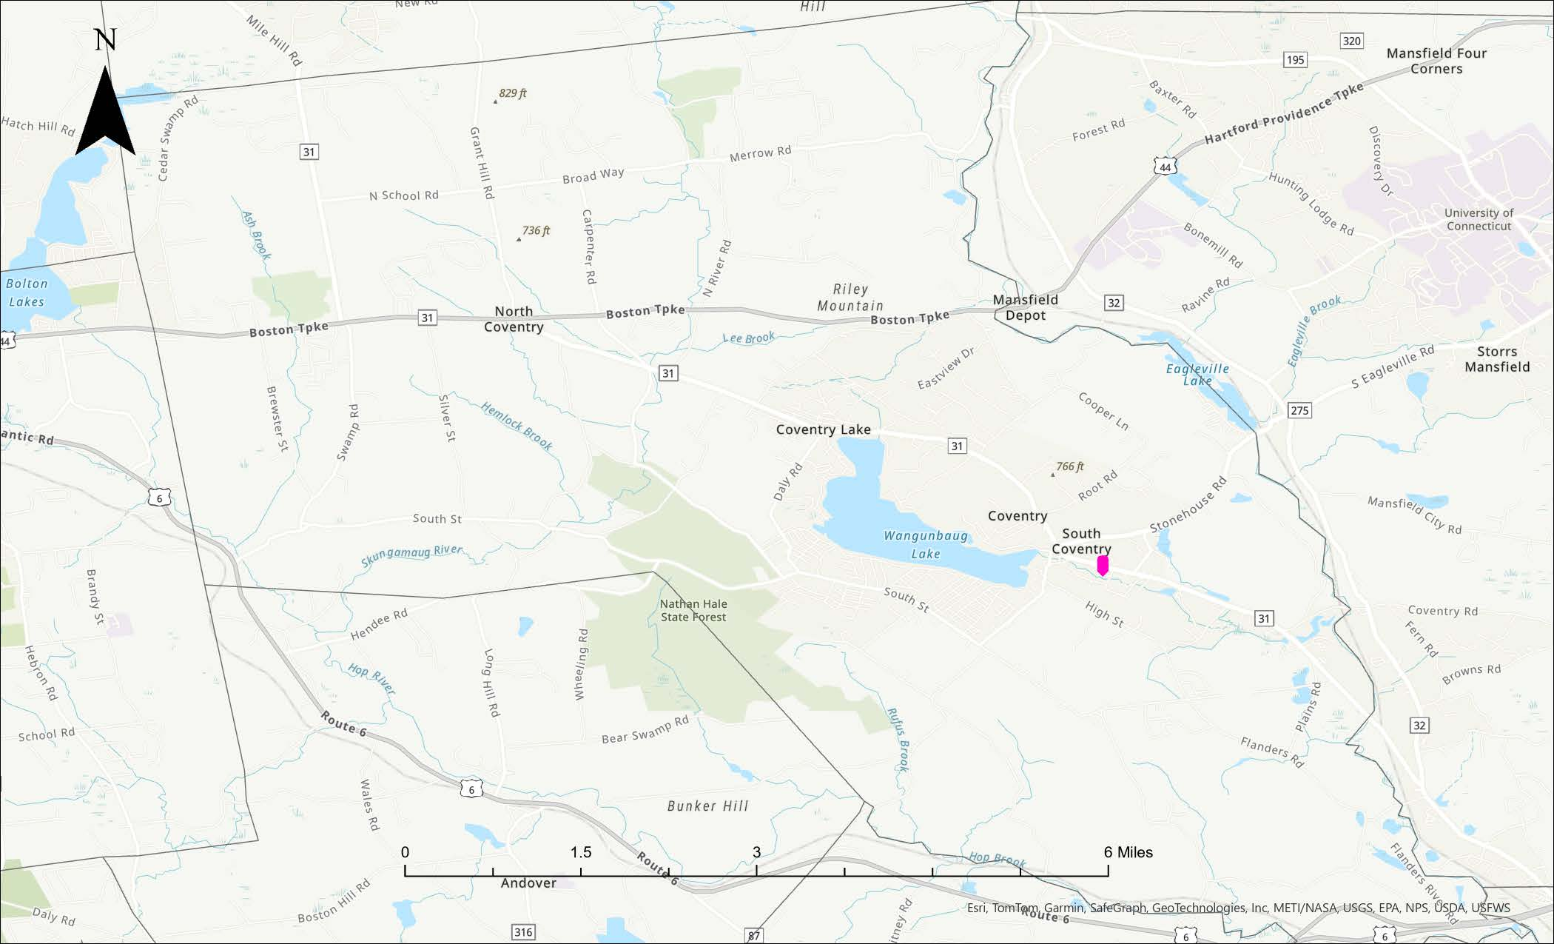
Figure 1. Map Showing the Target Site Location (Source: ArcGIS Pro)

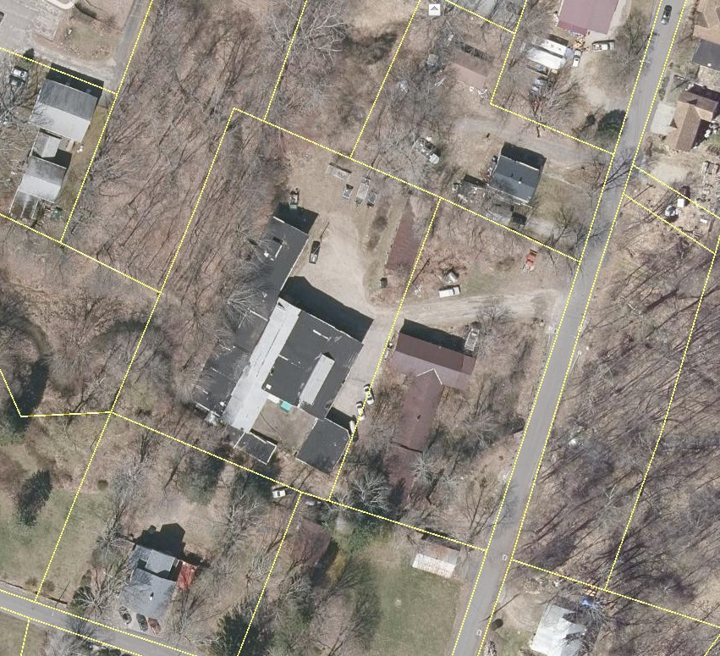
30
Mason Street
28
Mason Street
28
30
28
30
Figure 2. Target Site Parcel Map (Source: Town of Coventry, CT GIS)

UConn-TAB used the USDA’s Natural Resources Conservation Service (NRCS) Web Soil Survey to identify soil conditions at the Target Site (Appendix B). The soil type for most of the Target Site is identified as “Urban Land Complex”, though the southeastern corner of the 28 Mason parcel is partially mapped as “Ridgebury, Leicester, and Whitman Soils, 0 to 8 percent slopes, extremely stony.” The ground surface at the Target Site is relatively flat or gently sloping, with elevation decreasing by about 10 ft. from the northwest corner of 30 Mason to the southeast corner of 28 Mason Street (Figure 3, Appendix C). A key feature of the Site is the Mill Brook, which was the former power source for each mill, and which flows under portions of the buildings on both 28 and 30 Mason Street.
Groundwater at the Target Site is classified by CT DEEP as “GA, GAA - may not meet current standards.” This classification indicates that groundwater is designated for use as drinking water supply without treatment, and/or is the source of water for existing private/potential public or private supplies; however, CT DEEP is aware of contamination in the area that may cause the groundwater quality to not meet the standard for GA, GAA areas (Appendix D).

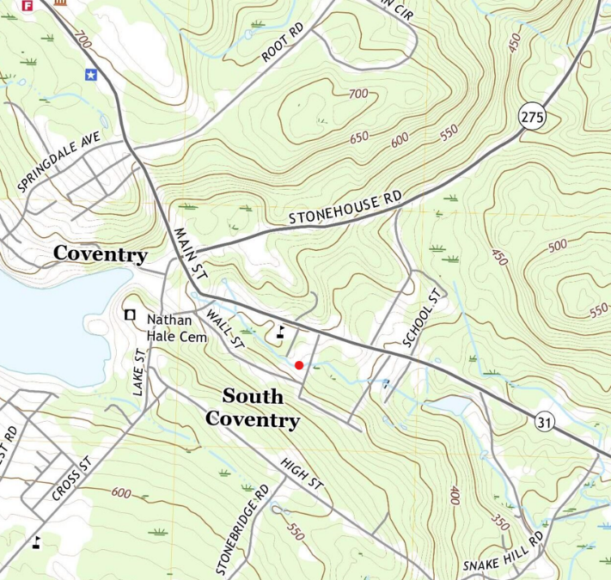
Figure 3. Excerpt from USGS Topographic Map for Town of Coventry [Approximate Target Site Location in Red Dot] (Source: United States Geological Survey (USGS))

SECTION 3 - NEIGHBORHOOD CHARACTERISTICS

3.1 DEMOGRAPHICS
According to U.S. Census Bureau population estimates from the American Community Survey (ACS), updated in 2021, The Town of Coventry has 12,254 residents. From 2011-2021, the Town’s population stayed relatively stable, mirroring trends experienced by Tolland County and the State of Connecticut in that same period (Figure 4). A notable decrease in population in 2011 was equally countered by a population increase in 2012, and a decrease in population in 2021 may be attributed to the unique migration patterns experienced around the nation at that time related to the COVID-19 pandemic. As shown in Table 1, the Town of Coventry is a predominantly owner-occupied, white community, with, on average, less poverty and higher incomes compared to the rest of the State. Median rent and median home value are slightly less than the State as a whole, with a comparable vacancy rate, illustrating a relatively stable housing market. There is less diversity in housing tenure (i.e., renter vs. owner-occupied) in Coventry—current and future residents may benefit from greater availability of renter-occupied residences.

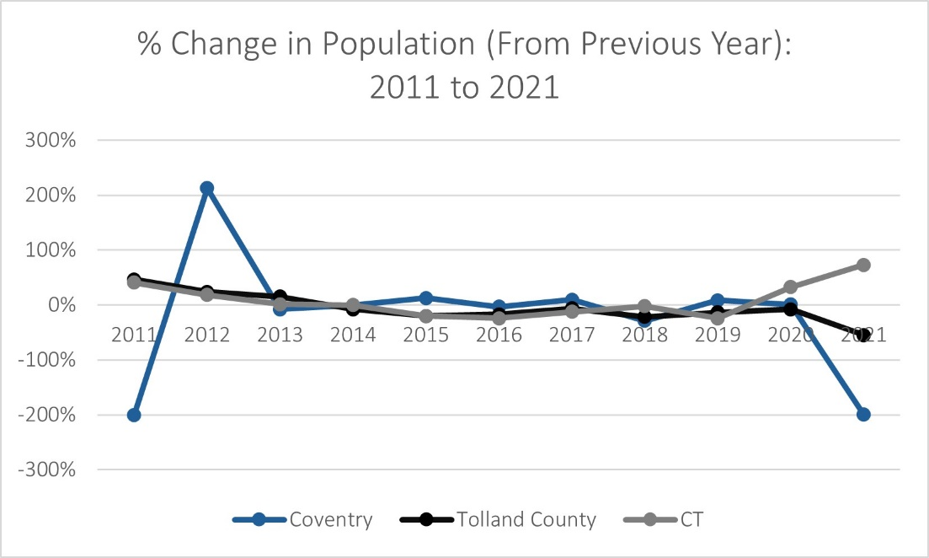
Figure 4. Population Trends, 2011 to 2021 (Source: U.S. Census Bureau)
Table 1. Demographic Data (Source: U.S. Census Bureau)
Demographic Variable | Coventry | State
Median Age | 44 | 41
% White | 90% | 65%
% Speak English at Home | 95% | 78%
Poverty Rate | 6% | 10%
Median Household Income | $94,058 | $83,572
Vacancy Rate | 7% | 8%
Median Home Value | $256,300 | $286,700
Median Rent | $1,093 | $1,260
The Target Site is in South Coventry, a census-designated place with a population of 1,748 (Figure 5). The U.S. Environmental Protection Agency (EPA) Environmental Justice (EJ) Screening Tool, EJScreen, provides demographic and environmental health data for certain geographic areas to identify vulnerable and/or historically underserved and marginalized populations. According to EJScreen, South Coventry is in the 62nd percentile (U.S.) for population over 64, 87th percentile (U.S.) for environmental health risks related to the ozone, and 77th percentile (U.S.) for lead paint propensity. As such, South Coventry has a higher-than-average ozone risk, lead paint propensity, and proportion of residents over the age of 64 that may be more vulnerable to certain environmental hazards or hazardous building materials. The proportion of retired (aged 65+) residents in Town is expected to increase through 2035, while all other age groups are projected to decrease in proportion (Coventry Plan of Conservation and Development). No census tracts in Town are identified as “disadvantaged” according to the Climate and Economic Justice Screening Tool (CEJST) and the Town is not on the State of Connecticut’s “Distressed Municipalities” list.

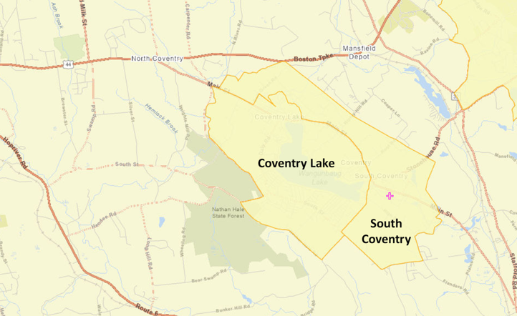
Figure 5. Geographic Boundaries of South Coventry Census Designated Place [Target Site Location Represented by Pink Marker] (Source: EJScreen)

3.2 PUBLIC FACILITIES AND SERVICES
As shown in Figure 7, The Coventry Public Schools District serves the Town with Pre-K through Grade 12 public education. Hale Early Education Center (Pre-K), Capt. Nathan Hale Middle School and Coventry High School (including Coventry Academy) are clustered together in an educational complex about one-mile northwest of the Target Site, and the George Hersey Robertson School (Grades 3-5) is less than one mile southwest of the Site. Coventry Grammar School (K-2) is about four miles from the Target Site. Enrollment in Coventry’s schools has experienced “moderate reductions” since 2008, and these trends are expected to continue (Coventry Plan of Conservation and Development).
Medical services available in the Town of Coventry include primary care, dental, and mental health services (Figure 8). There are no hospitals in the Town; the nearest is Windham Hospital, about 5 miles (11 to 13-minute drive) from the Target Site.
Many recreational opportunities are available for residents, including biking or walking trails, open green spaces or parks, and historic resources. Appendix E shows trail systems and open spaces in the Town of Coventry, many of which are in proximity to the Target Site.
Mill Brook Park abuts Mason Street to the west and Wall Street to the north (Figure 6). The Mill Brook Trail, part of the park complex, has an entrance just south of the 28 Mason Street building (Figure 9). The Coventry Ride 31-mile bike trail passes south of the Target Site along High Street before cutting north towards Main Street. Patriots Park and the Coventry Boat Launch on Wangumbaug Lake are less than a mile away.

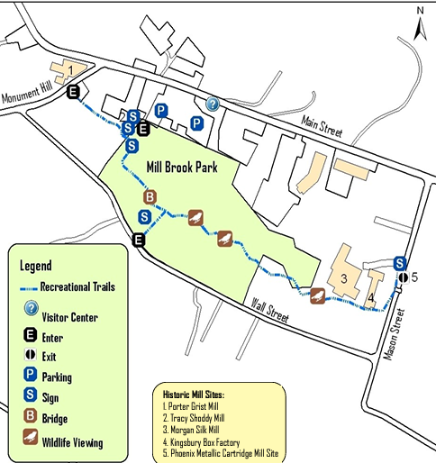
Figure 6. Excerpt from Mill Brook Trail and Park Brochure [Target Site is Buildings 3 and 4] (Source: Town of Coventry)
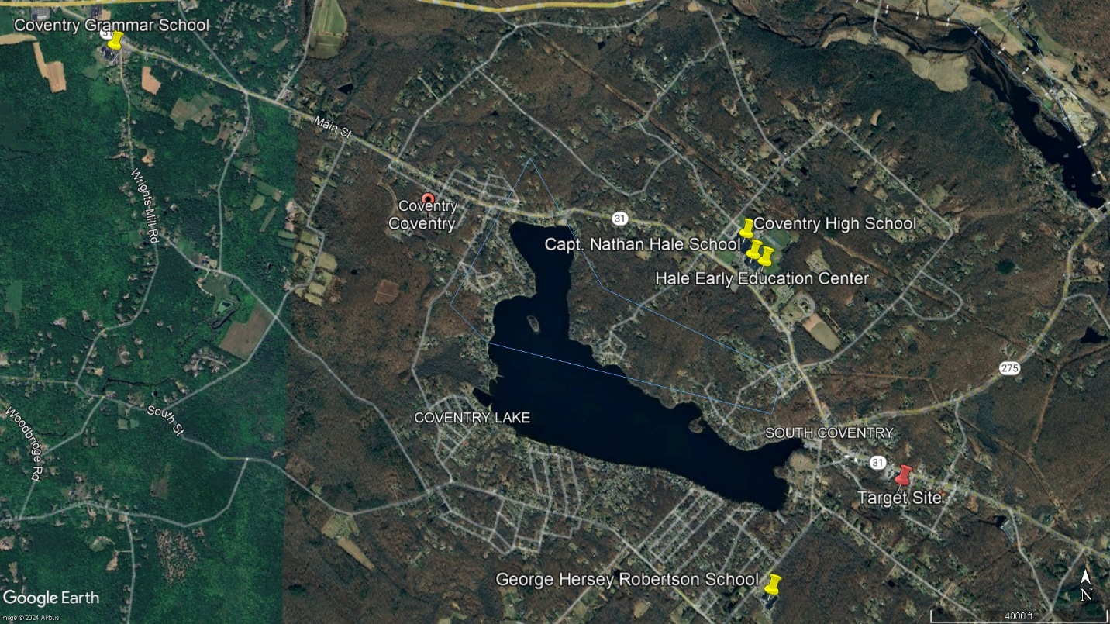
Figure 7. Schools in the Coventry Public School System (Source: Google Earth Pro)
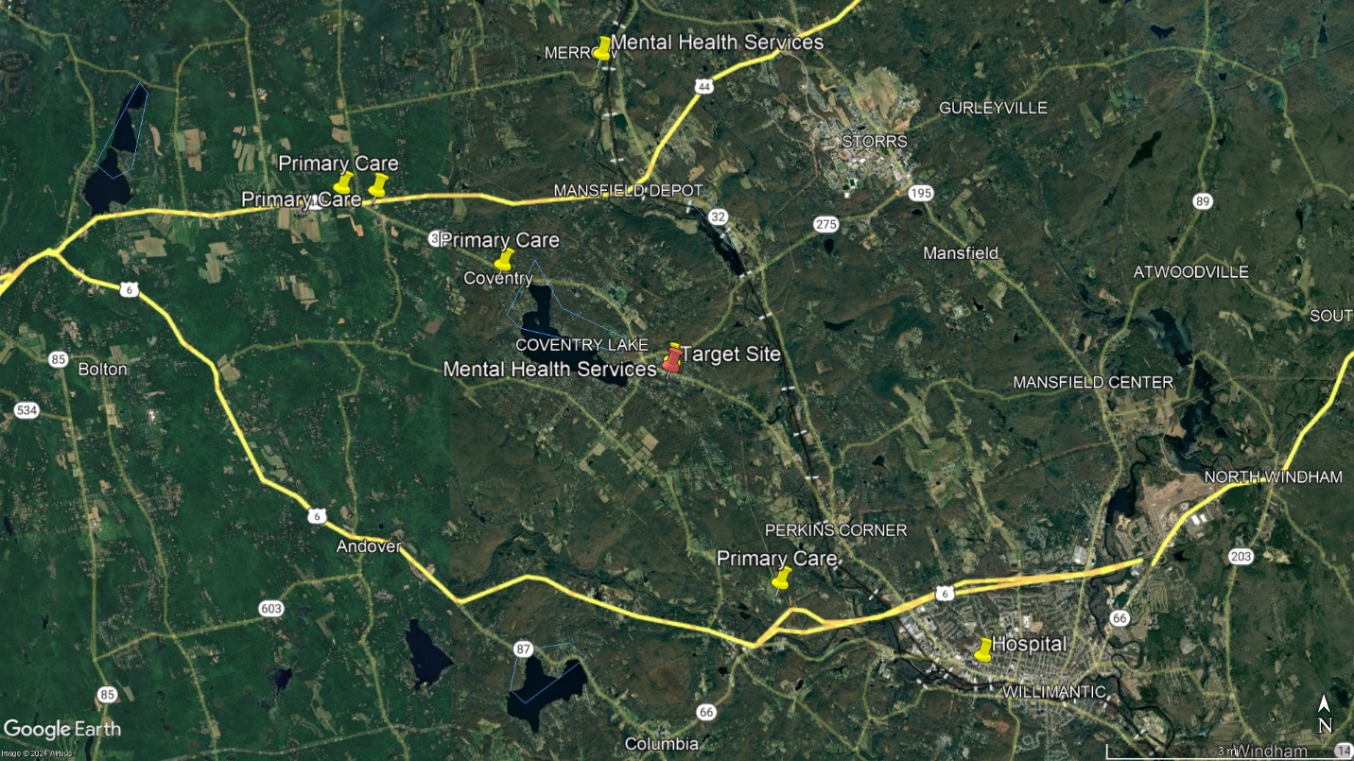
Figure 8. Medical Services in the Town of Coventry and Surrounding Communities
(Source: Google Earth Pro)

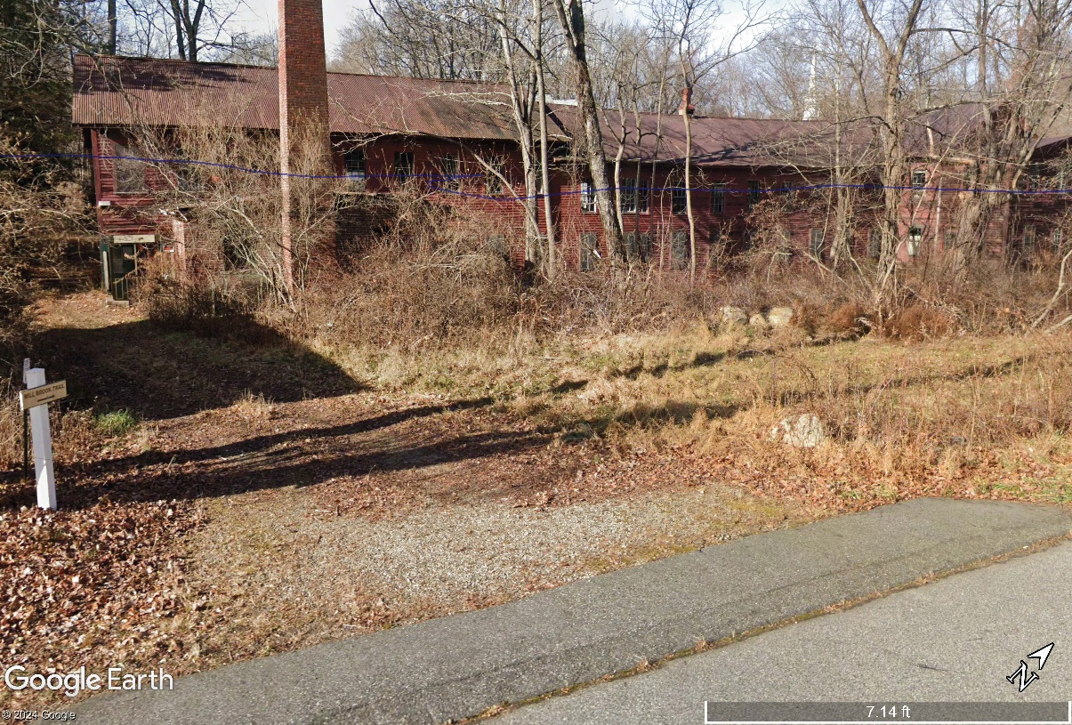
Figure 9. Entrance to Mill Brook Trail on Mason St.
[Sign in Left Corner of Image] (Source: Google Earth Pro)
According to information from Coventry’s 2020 Plan of Conservation and Development (POCD), the Coventry Fire Department is a volunteer organization with about fifty active members, serving from either the 1755 Main Street Station (about 1 mile from Target Site) or 1645 South Street (about 2 miles from Target Site). Emergency medical services are provided by the Fire Department and by private entities contracted through the Town, depending on the day of the week and/or time of day. The Town’s Police Department is a full-service law enforcement agency with sixteen officers, three full-time dispatchers, an executive assistant, and a community service officer.

FOOD ACCESS
The USDA Food Access Research Atlas is a tool used to identify geographic areas that have limited access to food (i.e., supermarkets). The Target Site is part of a Low-Access (LA) at 1 and 20 miles (LA 1 & 20) census tract, indicating that at least 500 people, or 33% of the population in the tract live farther than 1 mile (urban) or 20 miles (rural) from the nearest supermarket. The only grocery store in Town is a Highland Park Market about four miles from the Target Site; there is also a Price Chopper in Storrs which is also about four miles from the Target Site.

3.4 BUSINESSES
Mason Street is connected to Main Street about 250 feet northeast of the Target Site, where there is a concentration of commercial and business-related activities including restaurants, service businesses, churches, small shops (e.g., antique stores), and local services like the Town Library. CTData Collaborative annually provides new business formation data for Connecticut municipalities dating back to 1980. The Town of Coventry has experienced steady, consistent business growth since the 1980s, adding a total of 1,500 new businesses, or an average of 36 per year. Coventry’s growth in that period was only slightly behind its more populous neighbor, Mansfield, which saw 1,604 new businesses, or an average of 38 per year.

3.5 COMMUNITY STAKEHOLDERS
There are a variety of important local stakeholders that should be included in redevelopment planning and public visioning for reuse of the Target Site. The Town supports a wide array of boards and commissions that may be useful resources to that end:
- Conservation Commission
  - Keeps an inventory of all public/privately owned open areas in Town, sometimes providing recommendations to the Planning Commission plans/programs for the development and use of open areas in Town
- Housing Commission and Housing Rehab/Fair Housing Commission
  - Monitors current housing and ensures fair housing grant(s) are properly managed in Town
- Municipal historian
  - Assists in the identification and preservation of historical structures and sites, and produces resources for Coventry’s history
A full list of Coventry Boards & Commissions can be found here, with resources and responsibility descriptions for each. The inclusion of local businesses in planning efforts for the Site will help to minimize the displacement of current small businesses in Town. Local businesses along Main Street near the Site include, but are not limited to:
- Bidwell Tavern
- Woke Breakfast & Coffee
- Husky Pizza
- Nathan Hale Antique Center
- Coventry Arts and Antiques
- Small service businesses such as Clancy’s Hit & Fit or Allure Hair Studio
- Town Library
In addition to these local businesses, there are many churches near the Site. These entities are important community organizations that provide a sense of community and various charitable services throughout Coventry and the surrounding area. Churches near the Site include, but are not limited to:
- Second Congregational Church of Coventry
- First Congregational Church of Coventry
- Presbyterian Church of Coventry
- Prince of Peace Lutheran Church
- St. Mary’s Church
Other community groups that may have interest in the reuse of the Target Site include the Coventry Historical Society, Northeastern CT Chamber of Commerce, and Tolland County Chamber of Commerce.

SECTION 4 - SUMMARY OF PLANNING STUDIES
TOWN OF COVENTRY HOUSING AFFORDABILITY PLAN (2022)
The purpose of this plan was to “identify strategies to grow the number of affordable housing units over the next five years [2022-2027] in a manner that aligns with community values”. The recommendations and strategies identified in this plan were based on a wide consortium of information and housing data which cannot be described in entirety here, but some key takeaways include:
- A family of four making less than $79,900 per year or an individual making less than $55,590 per year could qualify for affordable housing in Coventry
- 26% of Coventry households, or 1,185 total, may be eligible for affordable housing programs (i.e., make less than 80% of Area Median Income)
- 4.7%, or 247 total, of Coventry’s total housing units were protected affordable units in 2022
- Coventry has some naturally occurring affordable housing (NOAH) units; however, “while these units may be affordable to low-income households today, they may not be affordable in the future if rents or home sale prices increase”
A housing gap analysis was conducted as a part of this plan, which compared the supply of “naturally occurring” affordable housing in the Town to local demand. The analysis concluded that Coventry would benefit from more owner-occupied and rental options for all low-income households, particularly for individuals living alone, seniors, and young people. Finally, the plan identifies ways that a more diverse selection of affordable housing options may benefit the Town of Coventry:
- Avoiding Displacement of Long-Time Residents
  - Growing the number of affordable housing units would allow those with roots in the community to continue living here, regardless of their economic status
- Young Adults
  - Affordable and diverse housing choices would allow young adults to move back to the community in which they grew up
- Seniors
  - Seniors would be able to remain in the community after they retire and have opportunities to downsize, should they choose
- Protecting Against Unavoidable, Sudden Loss of Income
  - Households that experience a loss of income due to economic circumstances, disability, divorce, or loss of a spouse, will not be displaced from the community, due to the inability to pay for housing
- Workers in Essential Jobs
  - Workers in essential jobs like teachers, grocery store workers, home health aides, childcare workers, restaurant workers, and first responders would have an opportunity to live where they work
- Supporting Local Business Development
  - Affordable housing can also support businesses by providing housing choices for entry-level workers
COVENTRY PLAN OF CONSERVATION AND DEVELOPMENT (POCD) (2020)
The purpose of the POCD is to “record wide-ranging community input and projections by experts on Coventry’s growth and give direction to public and private development that will define that growth”. The Plan’s objectives are designed to “look a decade or more into the future and then offer guidance on short and mid-term land use decisions”. Objectives identified in the POCD that may be relevant to the consideration of reuse options for the Target Site include:
- Actively re-use older buildings, particularly mill structures
- Minimize impervious surfaces in new development
- Promote a positive community image, as a “rural historic visitor’s destination”
- Collect greater citizen input
- Improve energy efficiency (i.e., solar energy on top of new developments)
- Promote stable residential developments of long-term quality with a favorable range of housing values and options
A citizen input survey was conducted in early 2019 by the National Research Center, Inc. (NRC) and the International City/County Management Association (ICMA) on behalf of the Town to complement expert opinions in the POCD. Comparing the results to a previous citizen survey conducted in 2008, it was observed that there was a perceived decline in the availability of “affordable, quality food” and an overall self-reported decrease in the use of public services, such as parks or the library. Other input from the community that may inform reuse options for the Target Site include:
- 65% of residents believe that “Coventry should encourage some commercial development to provide jobs, services, and tax revenue”
- Strong support (65%) for outdoor recreation
- The most popular choices for future business developments were a coffee shop/cafe (63%), a casual restaurant (62%), a small retail development (55%), or a sit-down restaurant (52%)
Coventry’s Historic Village District, containing the Target Site, is a priority for development. Chapter 11 of the POCD, which discusses goals and recommendations for the area, advocates for the redevelopment of the district’s former mill buildings, referring specifically to the Site as a target in such efforts. Additionally, the plan calls for the development of “adaptive re-use plans for the mills [in the Historic Village District] as new centers for commercial growth, [where] each mill may serve as a different thematic center for housing, although appropriate flexibility of land scale must be allowed”.
Section 13 of the POCD concerns “economic vitality”, with a standout goal of increasing the diversity of the Town’s tax base. Currently, the local tax burden is shouldered by residential property taxes, making up 96% of local tax revenue according to the 2016 Grand List Assessments of Real Property in Coventry. The rest (4%) is related to commercial assessment; the percentage of commercial assessment relative to the total in Coventry is one of the lowest in the State.

SECTION 5 - SITE-SPECIFIC CONSIDERATIONS

5.1 ZONING REGULATIONS
The Target Site is in the Village Center Zone (VC) of Coventry (Figure 10). Shown in Table 2, “Generally Permitted Uses” in the VC district are those that do not require site plan review by the commission. Any other uses are either “specially permitted uses” that require the issuance of a special permit or are permitted upon the issuance of site plan approval by the Zoning Commission. In addition to “generally permitted uses”, Table 2 also shows uses that are permitted in mill structures in the VC. More information on specially permitted uses in the VC district and the site plan approval process is available in Section 6.11 (pages 122-124 of the 12/16/23 amended version) of the Coventry zoning regulations. Table 3 gives the dimensional requirements (e.g., setbacks, building height guidelines, lot coverage guidelines) for any development in the VC district, which need to be considered and accurately followed in the development of reuses for the Site. Appendix F gives the parking requirements for developments in Coventry, based on the type and size of the desired use.
In addition to the Coventry Zoning Regulations, development at the site is subject to “Commercial Design Regulations” in Town. In particular, the following landscaping guidelines for parking lots need to be considered in reuse strategies for the Site:
- Less than 19 spaces: no landscaped island or heat-island-effect-minimizing features required
- 20-39 spaces: 10% of the parking lot area required to be interior landscaped islands
- 40 or more spaces: 15% of the total parking lot area is required to be landscaped
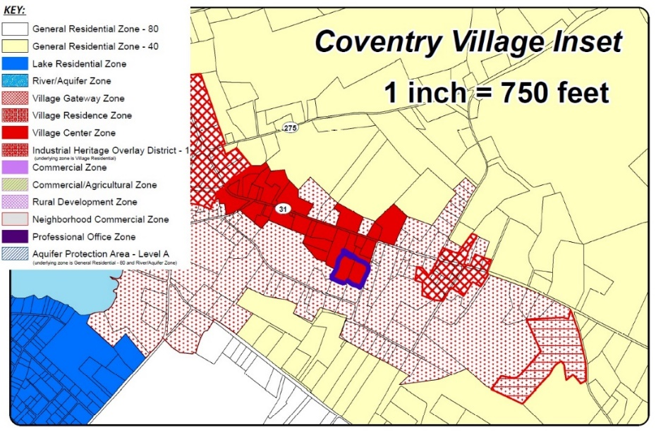
Figure 10. Zoning Map of Coventry Village; Target Site Outlined in Blue
(Source: Town of Coventry Zoning Regulations)
Table 2. Generally Permitted Uses in the VC Zone (Source: Town of Coventry Zoning Regulations)
Generally Permitted | Permitted in a Mill Structure Existing as of January 1, 2005
- Finance, insurance, and real estate services  - Offices  - Personal services  - Professional services  - Residential apartment (not on primary street level)  - Public museums  - Government services  - Tattoo studios | - Assembly  - Factory outlet  - Light manufacturing  - Office  - Residential uses  - Business uses  - Retail services
Table 3. Dimensional Regulations in VC Zone (Source: Town of Coventry Zoning Regulations)
Min. Lot Area (square feet) | 3000
Min. Lot Frontage/Width | 30
Min. Front Yard | 0 min, 10 max
Min. Side Yard | 0
Min. Rear Yard | 0
Max. Bldg. Height | --
Max. Impervious Coverage (%) | 90

5.2 FLOODPLAINS
According to the Federal Emergency Management Administration (FEMA) National Flood Insurance Program (NFIP) Flood Insurance Rate Map (FIRM) for the Town of Coventry, Connecticut, Tolland County, Panel 15 of 15, Map Number D901100015C, Effective Date: June 4, 1980, the Target Site is located entirely within Food Hazard Zone A – Areas of 100-year flood, or areas where base flood elevations and flood hazard factors have not been determined (Figure 11). (Note that, according to FEMA’s National Flood Hazard digital mapper, there is no modernized data to determine the flood hazard for the area including the Target Site; therefore, the 1980 FIRM map is the appropriate information to use to evaluate flood hazard).
This Flood Hazard Zone A is associated with Mill Brook, which passes through the Site and flows underneath the mill building at 28 Mason Street and the mill building at 30 Mason Street. A detailed flood study and risk assessment will likely be required before redevelopment to accurately ascertain the base flood elevation of the Mill Brook floodplain with updated information that may have not been available at the time of the map’s composition, and which must consider the anticipated effects of climate change, which are expected to increase flood zone elevations. Moreover, the reuse of the buildings at the Target Site, if applicable, should consider how flood mitigation strategies can be implemented to ensure the buildings may be safely used for their desired purpose(s).
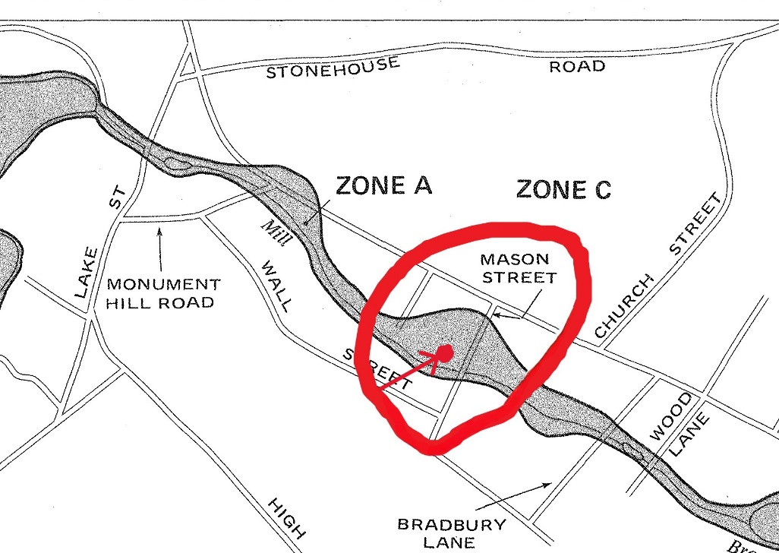
Figure 11. Portion of Flood Risk Assessment Map [Approximate site location circled in red] (Source: FEMA)

5.3 WETLANDS
Wetlands are an important consideration when analyzing a property for development and/or redevelopment not only because of their ecological importance but also the design implications, permitting requirements, and associated costs that addressing wetlands concerns may cause. When performing a preliminary assessment of the Site for the presence/absence of inland wetlands and watercourses, several national, State, and local data resources are utilized as well as on-site observation:
- The US Fish and Wildlife Service (USFWS) National Wetlands Inventory (NWI) as accessed on 7/11/24, identifies Mill Brook as a Riverine Habitat within the boundaries of the Site, having a Classification Code of R5UBH (Appendix G). The classification code breaks down as follows: R = Riverine; 5 = Unknown Perennial; UB = Unconsolidated bottom; and H = permanently flooded. There are Forested Scrub/Shrub wetlands associated with Mill Brook both westerly (upstream) and easterly (downstream) of the Site, but no other wetlands are indicated on the Target Site.
- The US Department of Agriculture (USDA) Natural Resources Conservation Service (NRCS) Web Soil Survey (WSS) identifies approximately 18% of the entire land area of the Site as Ridgebury, Leicester, and Whitman Soils, 0-8 % slopes, extremely stony (3) which is a hydric soil. These areas are depicted as occurring adjacent to Mill Brook, both westerly of the rear of the building at 30 Mason Road and easterly of the front of the building at 28 Mason Road, between the building and the road.
- The Town of Coventry Geographic Information System (GIS) identifies the approximate location of Mill Brook and also includes a data layer entitled “DEEP Inland Wetlands”, the boundaries of which are exactly coincident with the Ridgebury, Leicester, and Whitman Soils, 0-8 % slopes, extremely stony (3) soil map unit depicted on the WSS map.
- Observations by UConn TAB during a site visit on Tuesday, July 2, 2024, were consistent with the conclusion that Mill Brook is a perennial watercourse and there are associated wetlands along the riparian corridor and north of the rear of the building at 30 Mason Street and easterly of the front of the building at 28 Mason Street, between the building and the road. The property located northwest of the Site (1159 Main Street) contains two defined channels that appear to convey stormwater from Main Street (CT Route 31) to Mill Brook and may meet definitive criteria for classification as intermittent watercourses.
Based on the information above, the Site contains a perennial watercourse and inland wetlands, and possibly portions of one or more intermittent watercourses that will require field delineation by a qualified professional such as a soil scientist. The Agency having regulatory jurisdiction for the inland wetlands and watercourses on this Site is the Coventry Inland Wetlands Agency.

5.4 SOILS
As stated in previous sections, the US Department of Agriculture (USDA) Natural Resources Conservation Service (NRCS) Web Soil Survey (WSS) identifies that the roughly 1.74-acre Target Site is composed of four soil map units. Approximately 68% of the land area is mapped as Udorthents-Urban Land Complex (306), 18% as Ridgebury, Leicester, and Whitman Soils, 0-8 % slopes, extremely stony (3), 9% as Canton & Charlton fine sandy loams, 8-15% slopes (60C), and the remaining 5% is mapped as Charlton-Chatfield complex, 0-15% slopes, very rocky (73C) (Appendix B).
Of the many physical soil properties, suitability criteria, and associated limitations available via the Web Soil Survey, those that are primarily relevant to construction, stormwater management, and on-site utility considerations at the Site are summarized in Table 4, below.
As discussed in Section 6.1, the Town of Coventry sanitary sewer line passes through the Site and it is reasonable to assume that any redevelopment of the Site would involve using this sewer for wastewater disposal. However, if onsite wastewater treatment and disposal were considered, a suitability analysis would be required, including a subsurface soil investigation by a qualified professional, such as a licensed Civil Engineer, Soil Scientist, or Registered Sanitarian. Likewise, a soil and hydrologic investigation should be conducted before redevelopment, to ascertain the feasibility of certain uses and stormwater considerations on/in the Udorthents-Urban Land Complex found at the Site.
Table 4. Site Soil Characteristics (Source: USDA Web Soil Survey,
CT Hydrologic Soil Group Classifications, Web Soil Survey of CT)
Soil Map Unit Name  (Map Unit Symbol) | Udorthents-Urban Land Complex (306) | Ridgebury, Leicester, and Whitman Soils, 0-8 % slopes, extremely stony (3) | Canton & Charlton fine sandy loams,  8-15% slopes (60C) | Charlton-Chatfield complex, 0-15% slopes, very rocky (73C)
Approx. Percentage of Site Land Area | 68% | 18% | 9% | 5%
Hydric Soil | No | Yes | No | No
Hydrologic Soil Group | B | D | B | B
Drainage Class | Well Drained | Poorly Drained | Well Drained | Well Drained
Depth to Seasonal High Water Table | >80” | 0-6” | >80” | >80”
Parent Material | Human Transported Material | Coarse-loamy lodgment till derived from gneiss, granite, and/or schist | Coarse-loamy over sandy melt-out till derived from gneiss, granite, and/or schist | Coarse-loamy melt-out till derived from gneiss, granite, and/or schist
Restrictive Layer | Densic | Densic | Densic | Densic
Depth to Soil Restrictive Layer | >80” | 15-35” | 19-39” | >80”
Septic (SSDS) Absorption Suitability | Very Limited | Very Limited | Very Limited | Very Limited
Restrictions to Septic (SSDS) Absorption | Slope, Seepage, Depth to bedrock | Depth to Saturated Zone, Percolates Slowly | Slope, Seepage, Depth to bedrock | Slope, Seepage, Percolates Slowly
Suitability for Building with Basement | Very Limited | Very Limited | Somewhat Limited | Very Limited
Suitability for Building without Basement | Very Limited | Very Limited | Somewhat Limited | Somewhat Limited

5.5 PUBLIC DRINKING WATER SUPPLY PROTECTION (Including Service Areas)
According to available resources provided by the CT Department of Public Health (CT DPH) Drinking Water Section, the Target Site is not located within a Public Water Supply Watershed, a CT DEEP Aquifer Protection Area (APA), or a local Aquifer Protection Zone (APZ). The Site is located within the Service Area of the South Coventry Water Supply Company (PWSID CT0320051). Development and/or redevelopment within a public drinking water supply service area may involve additional considerations, regulatory requirements, and/or permitting procedures; however, it is assumed that drinking water would be provided to the Site by the public water utility and that development of onsite potable water wells would not be needed for any future Site use or redevelopment (Table 5).
Table 5. Site Water Characteristics (Source: CT DPH, CT DEEP)
Water Attribute | Applicable | Notes
Public Water Supply Watershed | No | None
CT DEEP Aquifer Protection Area (APA) | No | None
Local Aquifer Protection Zone (APZ) | No | None
Public Water Supply Service Area | Yes | South Coventry Water Supply Co.

5.6 NATURAL DIVERSITY DATABASE (State/Federal Listed Species & Critical Habitat)
For planning purposes, the CT DEEP Natural Diversity Database (NDDB) Area mapping identifies approximate locations of State and Federal listed species of flora and fauna, as well as Critical Habitats (unique combination(s) of flora and landforms) throughout the State. According to the NDDB mapping for Coventry, dated June 2024, there are no mapped occurrences of State/Federal listed species or Critical Habitats within the boundaries of the Target Site.

5.7 COMMUNITY VULNERABILITY TO EFFECTS OF CLIMATE CHANGE
The National Risk Index is a tool operated by FEMA that predicts community vulnerability to the effects of climate change. The Index measures expected annual loss (from storms, natural disasters, etc.), social vulnerability, and community resilience to assign a level of climate-related risk to every county and census tract in the U.S. The census tract containing the Site received high marks for community resilience, balancing the tract’s total risk index score to “relatively low”. This is not to say that this tract is excepted from the impacts of climate change, but that the community is relatively well-equipped to take on the increasing costs associated with the rising propensity of record-breaking natural disasters and phenomena. The most significant hazards identified for the tract were hurricanes, landslides, lightning, and ice storms. These hazards have predictable associated costs (i.e., “expected annual loss”). The most significant costs predicted for the tract are associated with an increased prevalence of hurricanes, tornadoes, and ice storms. Data from the National Oceanic and Atmospheric Administration (NOAA) indicates that Tolland County is predicted to experience consistent increases in average daily maximum temperature, well above the 1961-1990 observed average (Figure 12). As the risk and costs of natural disasters or climate-related events increase, steps should be taken to minimize the community’s vulnerability and maximize resilience, including but not limited to:
- Promoting energy-efficient designs of new buildings
- Utilize and increase renewable energy sources as much as possible (i.e., solar panels on roofs of new/existing developments)
- Flood resilient site design (i.e., vegetation, stormwater treatment, etc.)
- Minimization of impervious surfaces
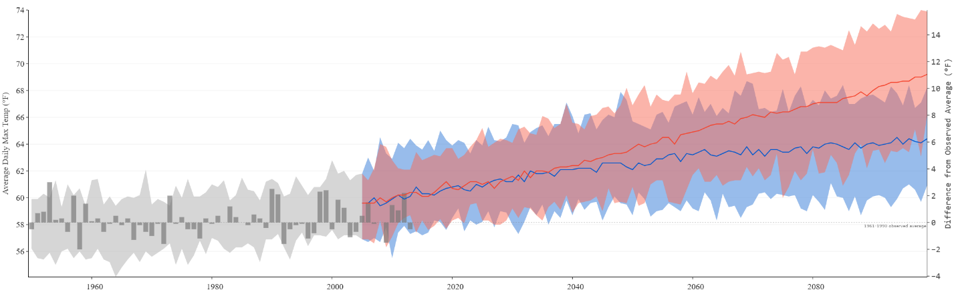
Figure 12. Predicted Average Daily Max. Temp for Tolland County Through 2080 [Blue = Scenario of Lower Greenhouse Gas Emissions, Red = Scenario of Higher Greenhouse Gas Emissions] and Difference from Observed Historical Average [Gray Area] (Source: NOAA)

SECTION 6 - TRAFFIC & INFRASTRUCTURE ASSESSMENT

6.1 UTILITIES
The property card for 30 Mason Street lists the parcel as connected to municipal sewer for wastewater, and well water for drinking water. The property card for 28 Mason Street lists a septic system associated with the parcel; the status and potential future usability of the septic system is unknown. Discussions with Town officials indicate that a municipal sewer connection will be required to meet wastewater needs for any reuse of the Site that requires public bathrooms and available potable water (e.g., mixed-use commercial and residential development, office space, restaurants, etc.) (Figure 13). However, Town officials also report that the existing sanitary sewer discharges to a subsurface sewage disposal system located about 1.5 miles southeast of the Site, and this system does not currently have the capacity for additional sewer connections. The Town has been researching the potential to expand the capacity of the sewage disposal system; preliminary cost estimates for the sewer expansion are $21 million. As an alternative to expanding the subsurface sewage disposal system, the Town has also considered connecting the sewer lines to the Town of Windham’s sanitary sewer system. Studies by the Water Pollution Control Authority (WPCA) are ongoing though there is no official Town plan to expand sewer capacity.
Drinking water is provided to the area by the South Coventry Community Water System operated by the Connecticut Water Company. According to the CT DPH, this water system has 116 residential connections and 25 commercial connections and serves a population of about 500. Future drinking water needs for the Site may be met by connecting to this community public drinking water system. While the groundwater classification for the Site indicates that groundwater is suitable for drinking without treatment, potential groundwater contamination at the Site may hinder drinkability. Although water is currently provided to the Site from an on-site well, redevelopment for residential or commercial purposes will require a connection to the community water system, unless the community system lacks sufficient capacity to provide water to the Site. In the event that Connecticut Water Company does not have the capacity to provide water to the Site, further investigation would be required to assess the feasibility of using on-site groundwater for drinking water needs.
Above-ground power lines along Mason Stret connect to a utility pole on the Site and then to the building at 30 Mason St. Electrical lights were turned on inside the 28 Mason Street building at the time of UConn-TAB’s site visit. The plan from WeBuildUS includes potential energy-efficient improvements to electrical/HVAC infrastructure at the Site, pursuant to the expected power needs for a commercial/residential mixed-use development (Figure 14). These utility improvements can be expected to change based on the size and content of the proposed Site reuse and are included herein for illustrative purposes only.
The property card for 28 Mason St does not indicate that the building is heated; however, UConn-TAB observed a boiler house, chimney, and above-ground oil storage tank located adjacent to the southwest corner of this building, indicating that the building was likely previously heated using fuel oil. The property card for 30 Mason St indicates the building is heated with fuel oil. The status and reusability of this oil-heating system is unclear. Energy-efficient heating systems, whether run by oil/gas, heat pumps, or electricity, should be included in reuse plans for the Site.
According to the Connecticut Broadband Availability Map, wireline broadband internet at appropriate speeds is available at the Target Site. Providers that serve the area include Frontier, Charter Communications, and T-Mobile.

Table 6. Utility Availability Matrix
Utility | Availability | Provider(s) | Notes
Public Water | Yes | South Coventry Water Supply Co. | No existing connection
Public Sewer | Yes | Coventry WPCA | Possible Limited Capacity
Electricity | Yes | Eversource | 3-phase present to Site
Natural Gas | No | Not Applicable | Can get local propane delivered
High-Speed Internet | Yes | Verizon, Charter, T-Mobile | Choice

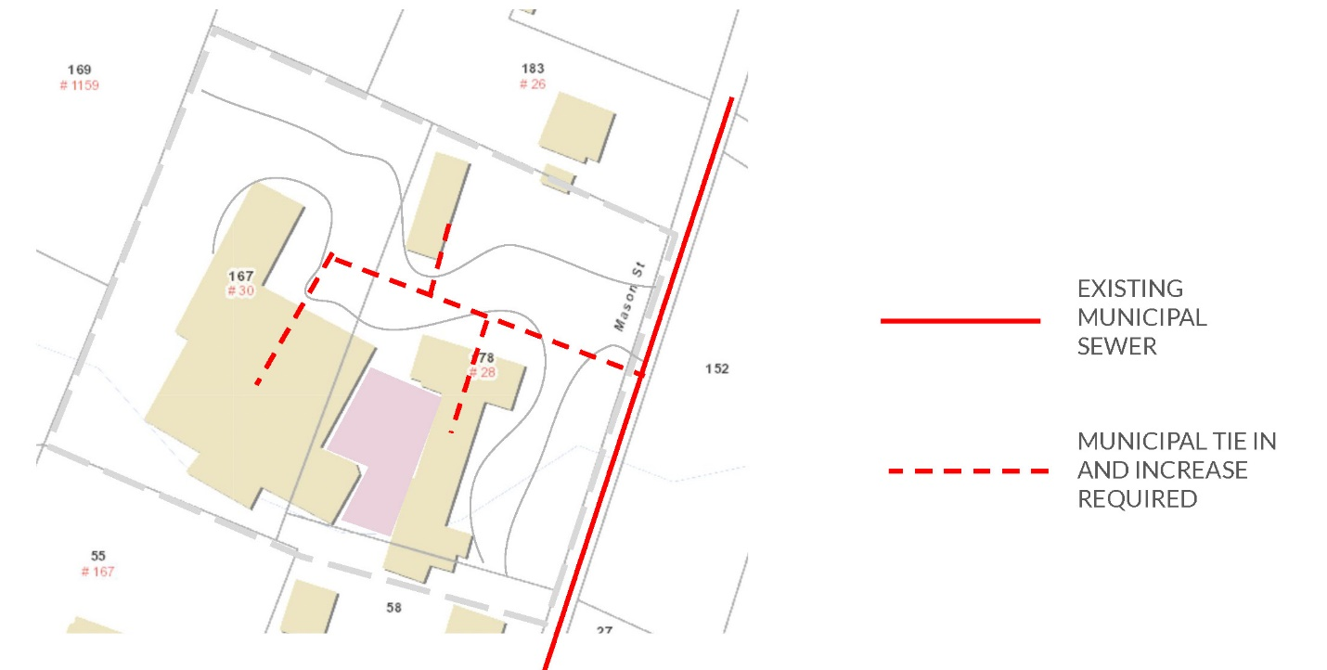
Figure 13. Potential Municipal Sewer Tie-In Plan (Source: Potential Site Plan by WeBuildUS)

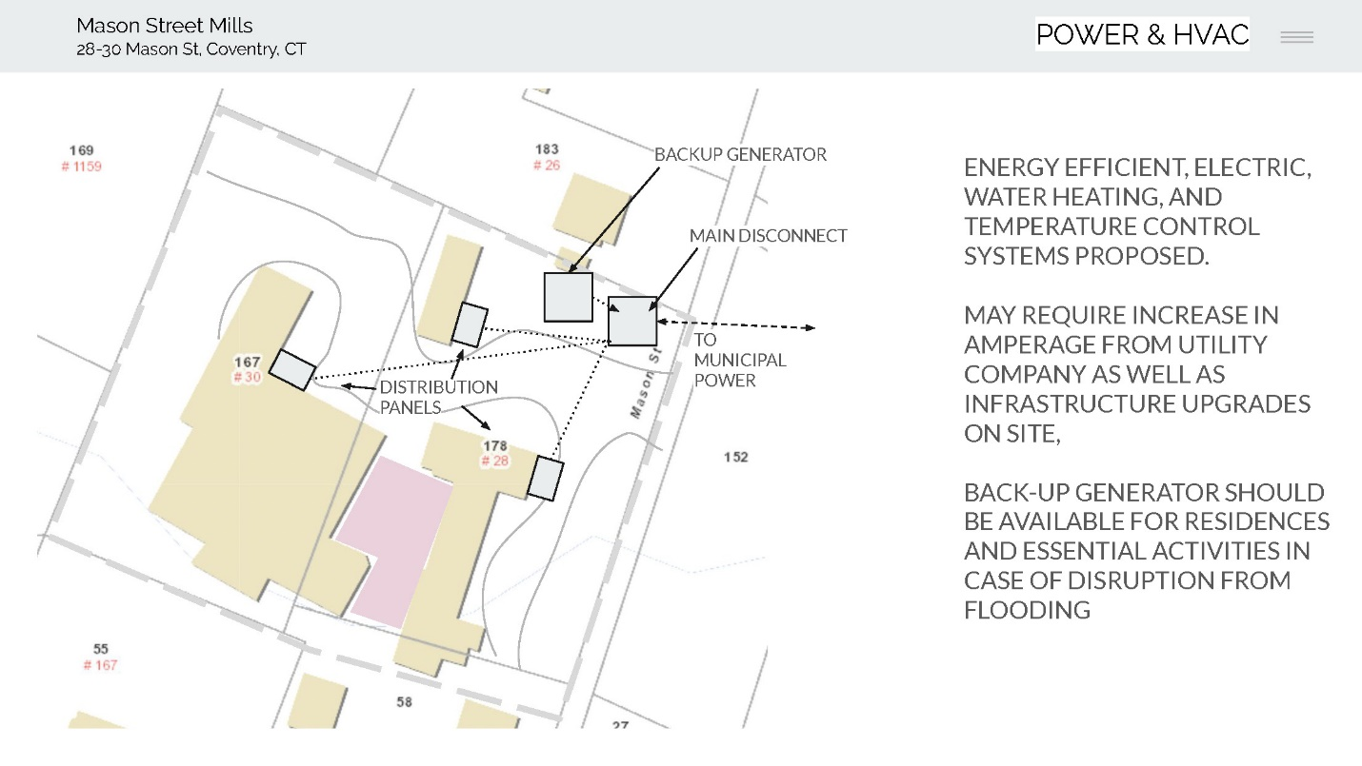
Figure 14. Potential Electrical/HVAC Improvements (Source: Potential Site Plan by WeBuildUS)

6.2 TRAFFIC ASSESSMENT
The Target Site is directly off Main Street (Rt. 31), which connects to major transportation corridors in the area: Rt. 44, Rt. 6. and Rt. 32. Rt. 44 continues east to Storrs/UConn and west to Manchester. Rt. 6 runs through the center of CT, connecting the western NY border to the eastern RI border. Rt. 32 runs north-south through eastern Connecticut, connecting to Massachusetts in the north and Norwich and New London at the Connecticut Shoreline. Mason St is a narrow residential road, only ~22 ft. wide, while Main Street is ~30 ft wide. Currently, the only vehicular entrance to the Site is on Mason Street (Figure 17).
Town officials have indicated that another potential entrance for the Site exists along Main Street, via the 1153 Main Street property that abuts the northwest corner of the 30 Mason Street parcel (Figure 15). An entrance to the Site from Main Street would provide for better traffic management for potential mixed-use activities at the Site, while mitigating traffic on Mason Street. The southern part of the 1153 Main Street parcel may also be used for additional parking for the Target Site and/or the Mill Brook Trail. Town Officials also indicated interest in the potential reuse of the 1159 Main Parcel (Figure 16) to allow for additional parking to accommodate commercial and residential reuse of the Site. There is limited public parking in proximity to the Site; most parking on Main Street is private parking for local businesses. As such, parking at the Site may be used by the public for other uses besides those associated with 28/30 Mason Street such as by people using the Mill Brook Trail. There are no public transportation (i.e., bus) stops in proximity to the Site.

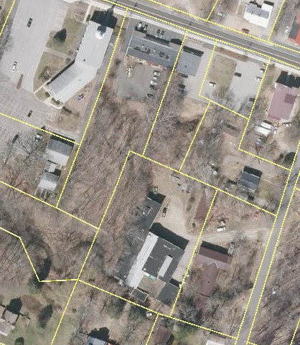
28
30
1153
Figure 15. 28 & 30 Mason St. and Portion of 1153 Main St. Used for Scenario B
28
30
1153
1159
Figure 16. 28 & 30 Mason St. and Portions of 1153 & 1159 and Main St. Used for Scenario C

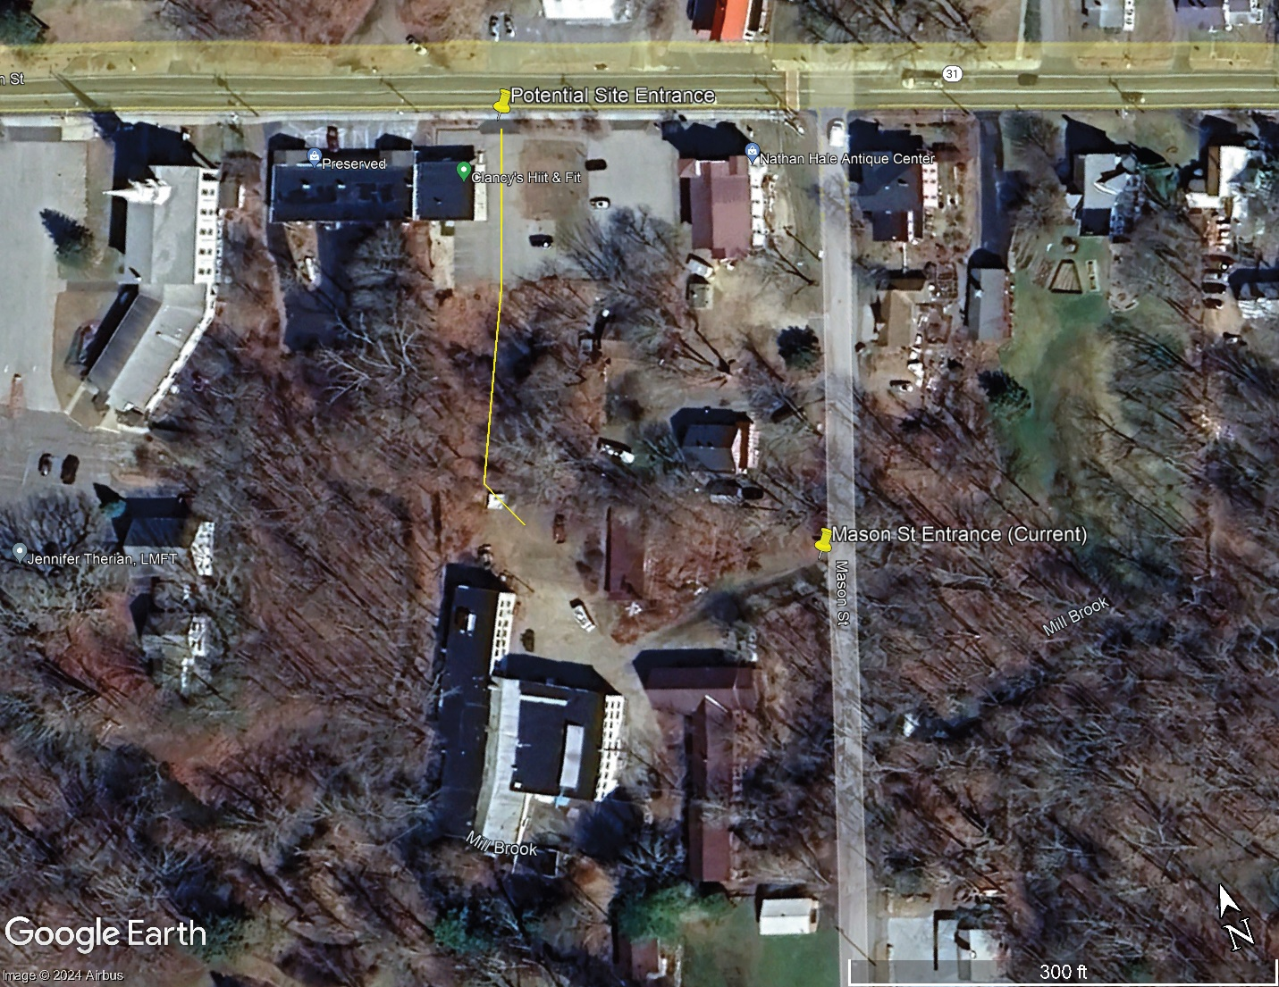
Figure 17. Existing and Potential Site Entrances (Source: Google Earth Pro)

SECTION 7 - ENVIRONMENTAL ASSESSMENTS

7.1 SUMMARY OF ENVIRONMENTAL SITE ASSESSMENTS
UConn-TAB conducted a search of the environmental databases of the CT DEEP for the properties at 28 Mason Street, 30 Mason Street, and 1153 Main Street. The databases searched included the List of Potentially Contaminated Sites – Remediation Division and Site Assessment and Support Unit Case Management System (also known as the leaking underground storage tank (LUST) database). These databases can be accessed at the CT Data website (https://portal.ct.gov/deep/remediation--site-clean-up/list-of-contaminated-or-potentially-contaminated-sites-in-connecticut). None of these three properties were listed on these databases, indicating that contaminant releases are not known to have occurred on these properties and that these properties are not known to have been have not been the subject of environmental investigations or regulatory enforcement.
UConn-TAB also reviewed the CTDEEP Remediation Divisions Document Portal, accessible here: https://filings.deep.ct.gov/DEEPDocumentSearchPortal/. This portal includes scans of historical CTDEEP documents and may contain documents pertaining to a property, even if the property is not listed in a CTDEEP database. A single document was found in the CTDEEP portal pertaining to the Site; this was a CTDEEP Emergency Incident Report Form, dated January 14, 1991. The report indicated that a gasoline release from an Underground Storage Tank (UST) occurred in Jan 1991 and affected indoor air and possibly groundwater. This release was reported to the State, indicating “Tank Failure” and “Water & Gas” in the gas tank. We infer from this information that gasoline had leaked out of the UST and water had entered the UST. The form also indicated “None” concerning cleanup actions, suggesting contamination from this incident may remain on the Site. The form indicated “Abandoned” as tank status and indicated that 3 other USTs were present on the property; there was no information to indicate the location or status of these other three USTs, suggesting that these USTs were likely not investigated and indicating that these USTs may still be in the ground. There were no other files about this incident in the CTDEEP portal, suggesting that there was likely no further investigation of the release.
UConn TAB did not observe direct evidence of USTs on the Site; however, in the paved area directly south of the 30 Mason St. building, an asphalt patch was observed about the size and shape of a typical UST grave. Moreover, this asphalt patch area was immediately adjacent to a chimney and outdoor fuel oil above-ground storage tank (AST). These observations suggest the possibility that the asphalt patch marks the location of a former and/or current UST that may have been associated with the heating system for the 30 Mason Street building; however, additional investigation would be needed to evaluate the Site for potential former or existing USTs.

7.2 REMEDIAL RESTRICTIONS
As stated above, the Site has not been the subject of formal investigations or remediation. No remedial restrictions are known to have been recorded on the Site parcels.

SECTION 8 - REDEVELOPMENT SCENARIOS

8.1 CRITERIA FOR REUSE ASSESSMENT
Discussions with Town Officials indicated that strong interest exists in preserving the existing buildings for future reuse. As such, redevelopment Scenarios A, B, and C include all existing buildings. Scenario D describes possibilities for the Site without the buildings. Except for the number of units proposed, buildings in Scenario A, B, and C are designed to be reused in the manner outlined in the WeBuildUS plans, with commercial/retail space on the bottom floor of the 28 Mason Street building, a tea & espresso bar and leased coworking offices, and residential amenities on the bottom floor of the 30 Mason Street building, and artist studios in the existing metal shed (Figure 18). It is assumed that all remaining floor space, including on the second and/or third floor of both buildings, will be utilized for residential units. The WeBuildUS Plans outlined the space available for residential development within the Site buildings (Figure 19). The square footage totals (not the unit counts) for each building floor shown in Figure 19 were used to develop potential unit counts for Reuse Scenarios A-C.
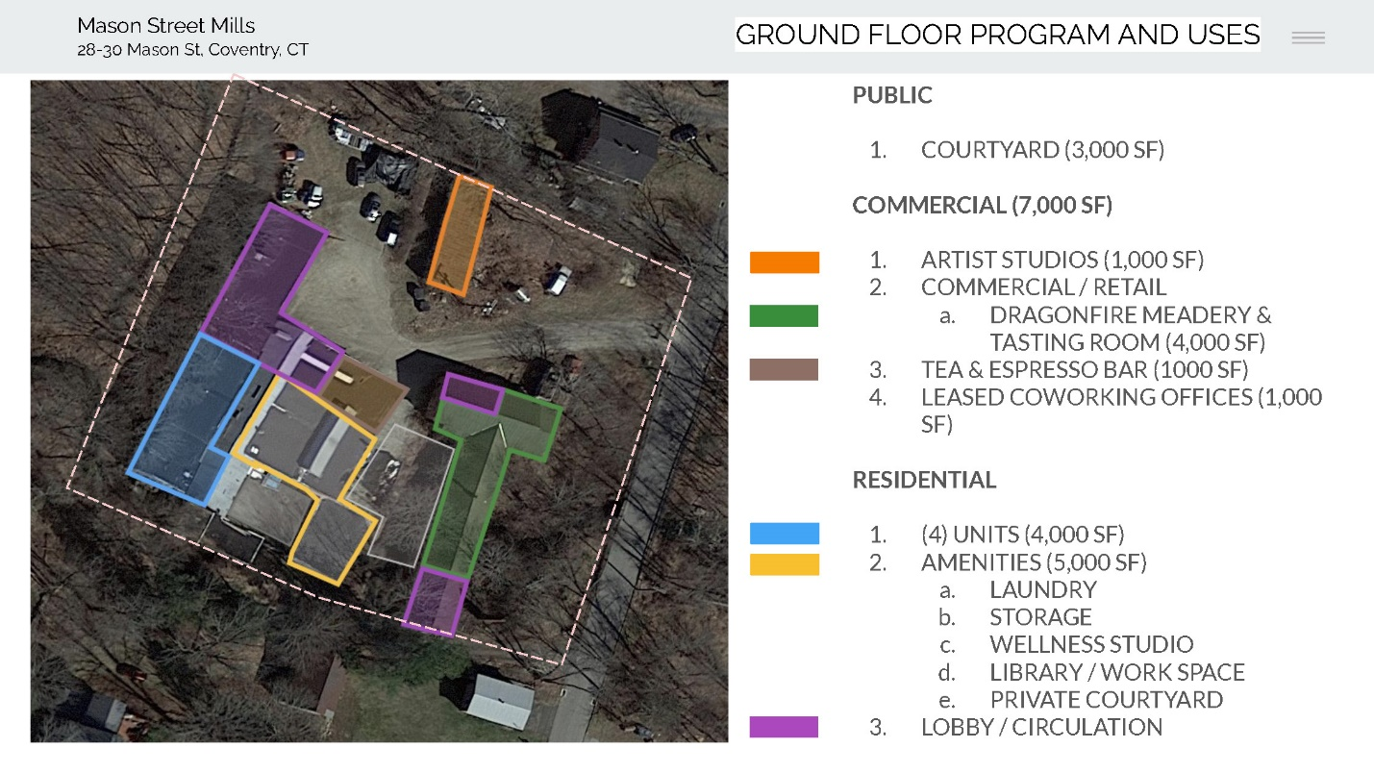
Figure 18. Proposed Ground Floor Use Plans (Source: Potential Site Plan by WeBuildUS)

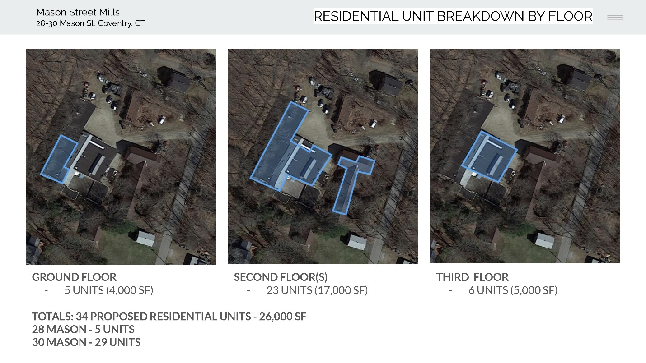
Figure 19. Breakdown of Proposed Residential Units (Source: Potential Site Plan for WeBuildUS)
Space for parking is a notable limitation to redevelopment at the Site, particularly for multi-family residential uses that require at least two parking spaces per unit. As such, one Reuse Scenario (Scenario A) will be composed of just the 28 and 30 Mason Street parcels, while a second Reuse Scenario (Scenario B) will include the 1153 Main Street parcel for increased parking space and additional site access along Main Street. A third redevelopment scenario (Scenario C) will include the 28 Mason, 30 Mason, 1153 Main, and 1159 Main St parcels
Although only reflected minimally in the renderings for Scenarios A and B, natural or artificial barriers to mitigate flood risk and human contact on Mill Brook are recommended. Scenarios A and B show small pedestrian bridges over the Brook and vegetation along the Brook’s edge to allow for site connectivity without leading to significant human intrusion into the wetland.
Solar panels should be considered on top of existing buildings to promote sustainable energy efficiency at the Site, although these are not included in the renderings. The redevelopment Scenarios assume the Site has access to municipal water supply or sufficient on-site water, not visually represented in the renderings. This rendering also assumes the Site soil and groundwater are cleaned to comply with applicable standards for residential and limited commercial use, as well as a small outdoor recreation piece (courtyard area between buildings).
Planning studies have identified support for commercial development in Coventry, including a coffee shop/café, space which will be included in both redevelopment Scenarios. Studies also call for a more diverse selection of affordable housing options in Coventry, which should be considered when choosing the size and number of units at the Site.
Due to technical software constraints, the slight slopes at the Target Site along the western corner of the 30 Mason St parcel and 1153 Main St parcel are not shown in the 3-D renderings in section 8.2. While still factored into considerations like stormwater and runoff mitigation, the Site topography does not constrain redevelopment shown in Reuse Scenarios A-C, as most of the Site is flat. Excluding topography, renderings are geolocated and to-scale.

8.2 REUSE ALTERNATIVES
Scenario A: Mixed-Use Housing and Commercial
The WeBuildUS plan, in addition to various commercial amenities, proposed 34 units of housing totaling 26,000 SF with 60 parking spaces totaling 30,000 SF of area including driveways, which would not be sufficient to meet Town zoning requirements. Coventry zoning regulations require 2 spaces per dwelling unit, as well as 1 space per 250 SF GFA for commercial and office space uses. The rendering for Scenario A includes 39 parking spaces, allowing for 12 dwelling units (Table 7). This would require at least ~6,300 SF and require ~950 SF of vegetated area to fulfill the Coventry zoning requirement of 15% landscaped parking area. Seen in Table 8, excluding space for hallways and utilities, this could allow for the following sizes and quantity of residential units in each building:
- 30 Mason St Building: 10 Units
  - Three ~1,300 SF
  - Five 2,800 SF
  - Two 2,500 SF
- 28 Mason: 2 Units
  - Two 1,500 SF
Table 7. Reuse Scenario A Parking Requirements
Use | Parking Requirement | Total GFA (or # Units) in Reuse Scenario | Total Required Parking
Residential | 2/dwelling unit | 12 Dwelling Units | 24
Commercial | 1/250 GFA | 1,700 SF GFA | 7
Office Space (inc. Artists’ Studio) | 1/250 GFA | 2,000 SF GFA | 8
Totals: | - | 17 dwelling units + 3,700 SF GFA | 39
Table 8. Reuse Scenario A Unit Count Breakdown
 | 30 Mason |  |  | 28 Mason |  |  | Totals
 | SF/Unit | # Units | Total SF Available | SF/Unit | # Units | Total SF Available | Proposed Unit Count | Total SF Available
Ground Floor: | ~1,300 | 3 | 4,000 |  |  |  | 3 | 4,000
Second Floor: | 2,800 | 5 | 14,000 | 1,500 | 2 | 3,000 | 7 | 17,000
Third Floor: | 2,500 | 2 | 5,000 | - | - | - | 2 | 5,000
Totals: |  | 10 | 23,000 |  | 2 | 3,000 | 12 | 26,000

Figures 20 to 29 show to-scale 3-D renderings of Scenario A created using SketchUp Pro 2024 and Lumion Student.
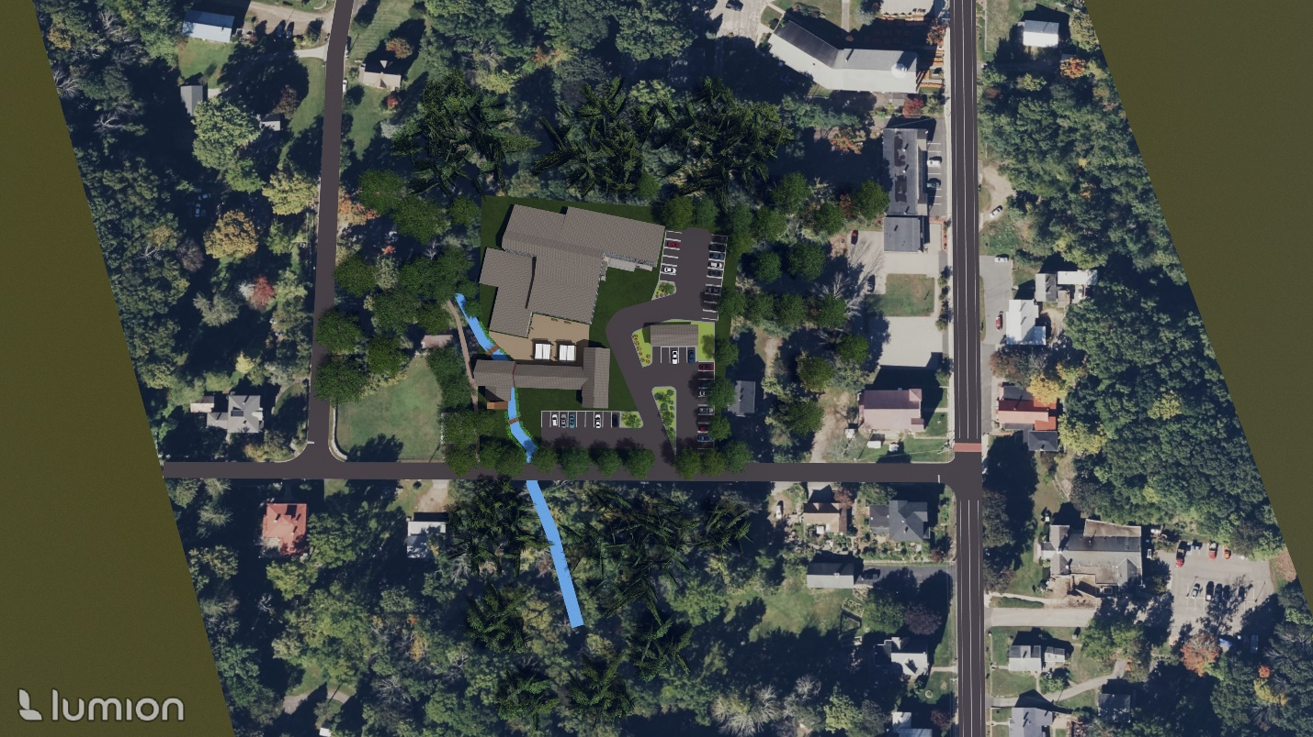
Figure 20. Scenario A: Birds’ Eye View

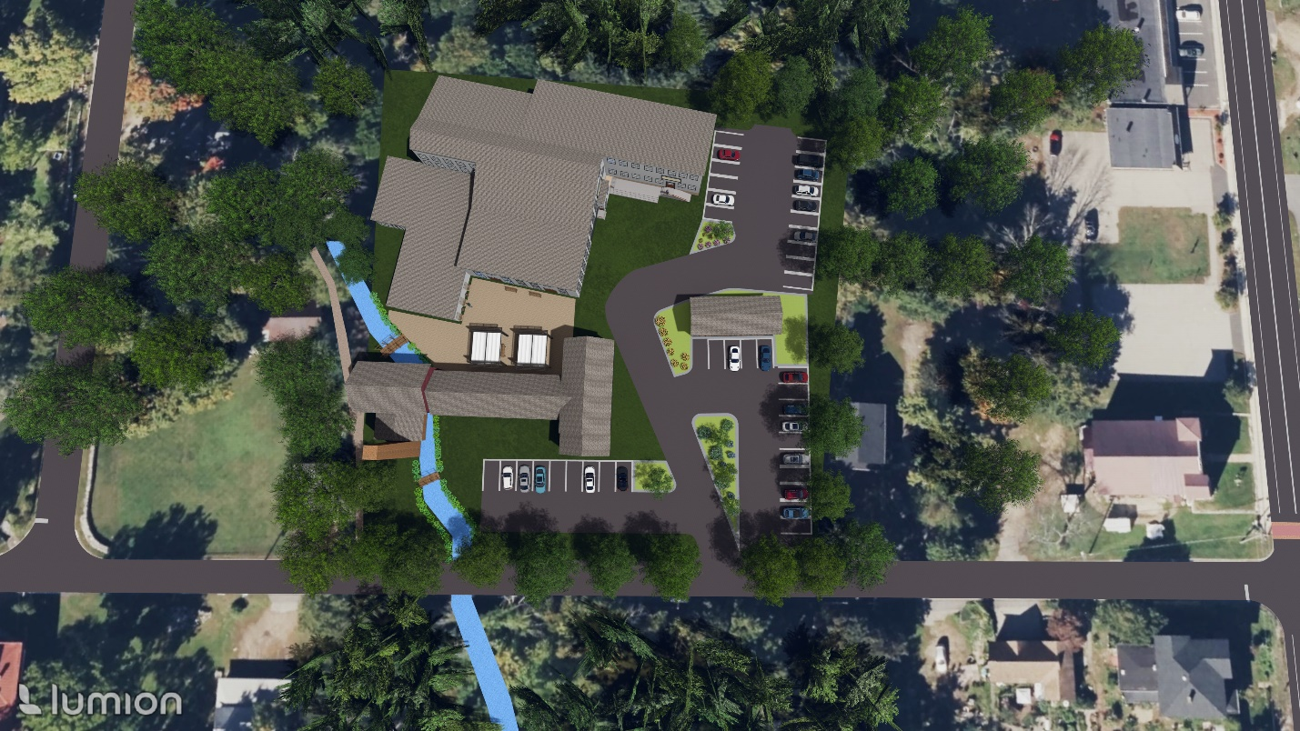
Figure 21. Scenario A: Zoomed-In Birds’ Eye View
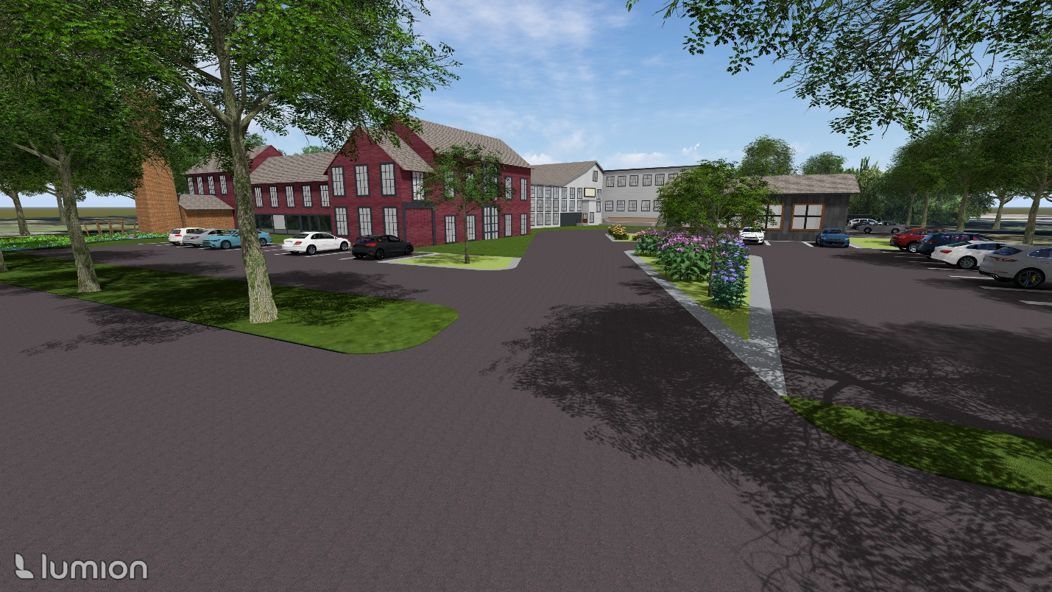
Figure 22. Scenario A: Ground View from Mason St Site Entrance [Facing ~West]
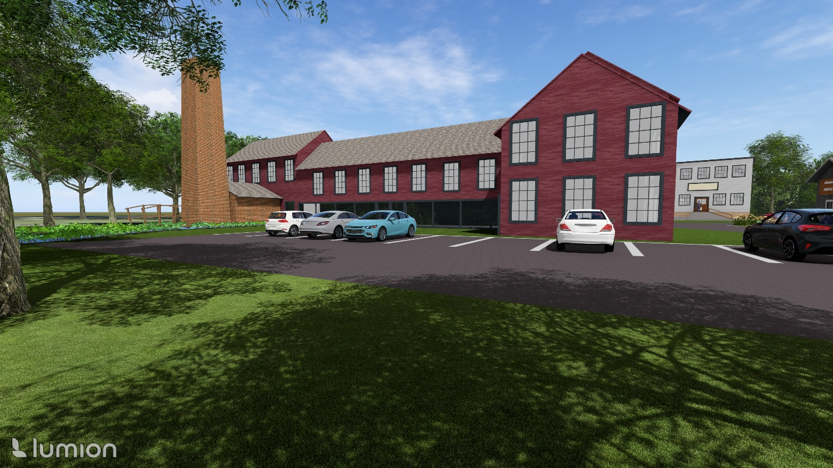
Figure 23. Scenario A: Ground View of 28 Mason Parking for First-Floor Commercial Use [Facing ~West]
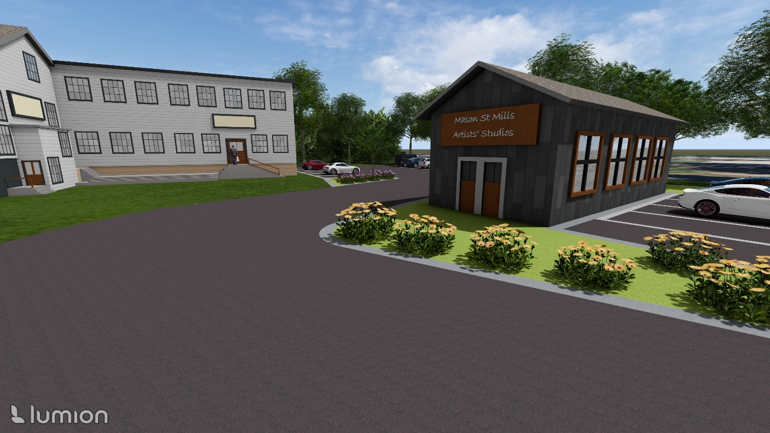
Figure 24. Scenario A: Ground View of Artists’ Studio and Northern Corner of 30 Mason St. Building [Facing ~North Towards Main St.]
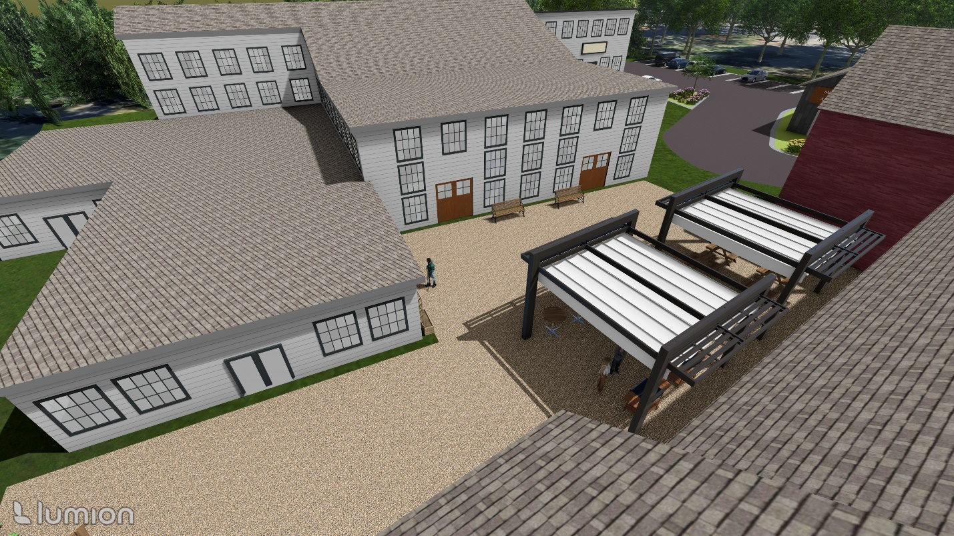
Figure 25. Scenario A: Birds’ Eye View of Patio Area [Facing ~Northwest]
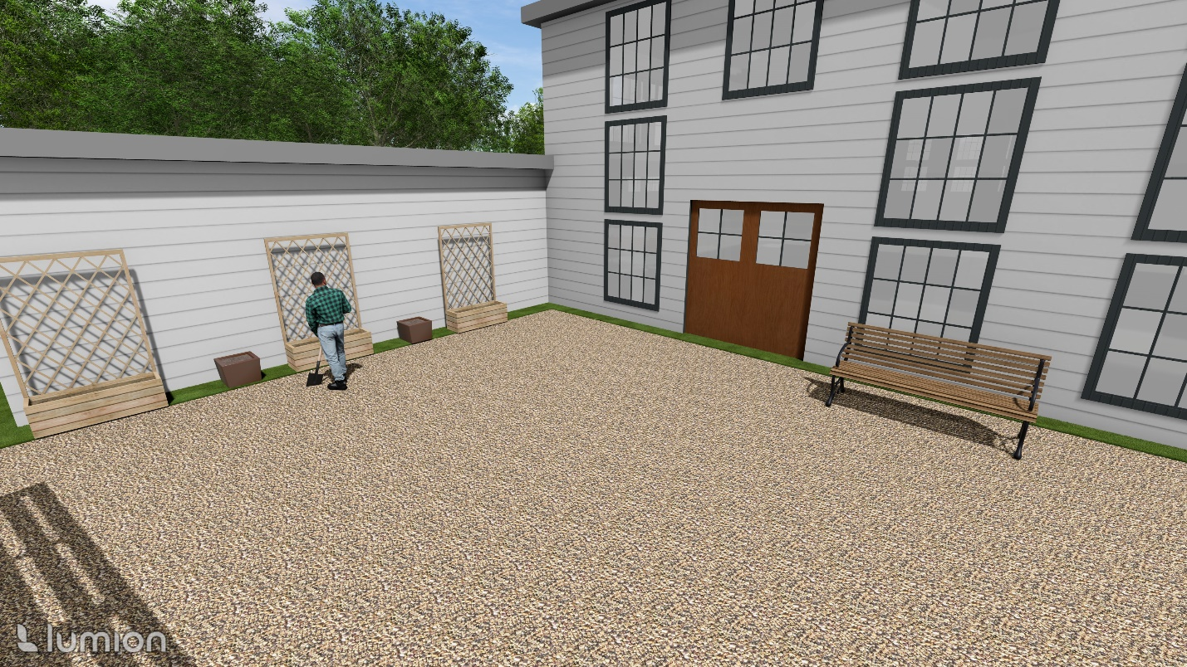
Figure 26. Scenario A: Ground View of Patio Area [Facing ~West]
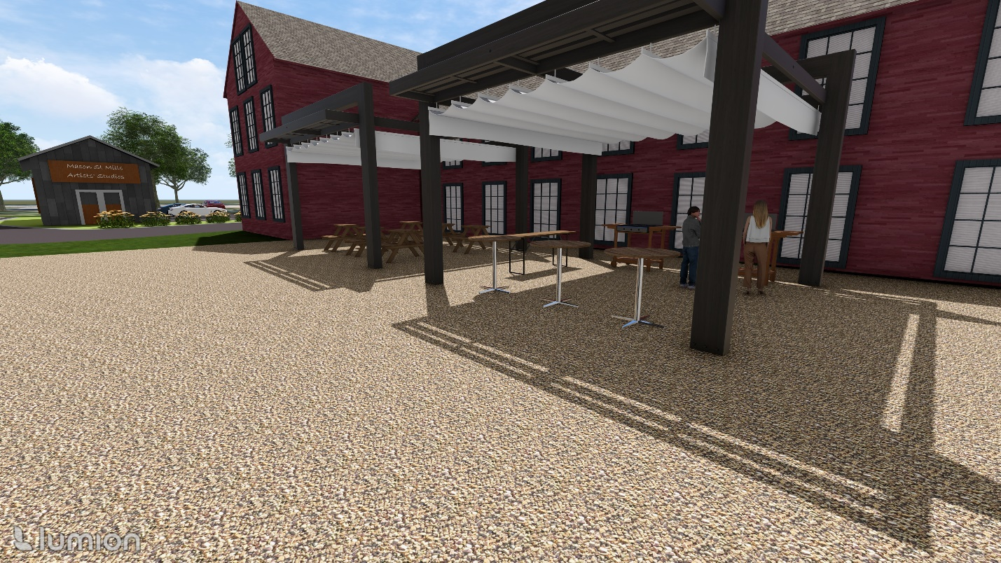
Figure 27. Scenario A: Alternative Ground View from Patio Area [Facing ~East]
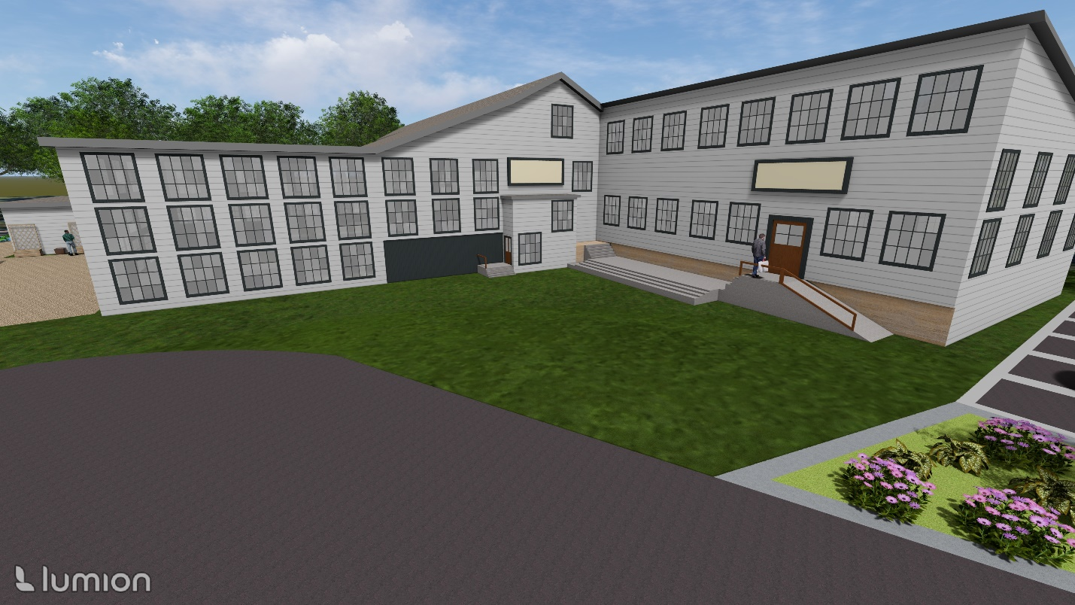
Figure 28. Scenario A: Front View of 30 Mason St Building [Facing ~Northwest]
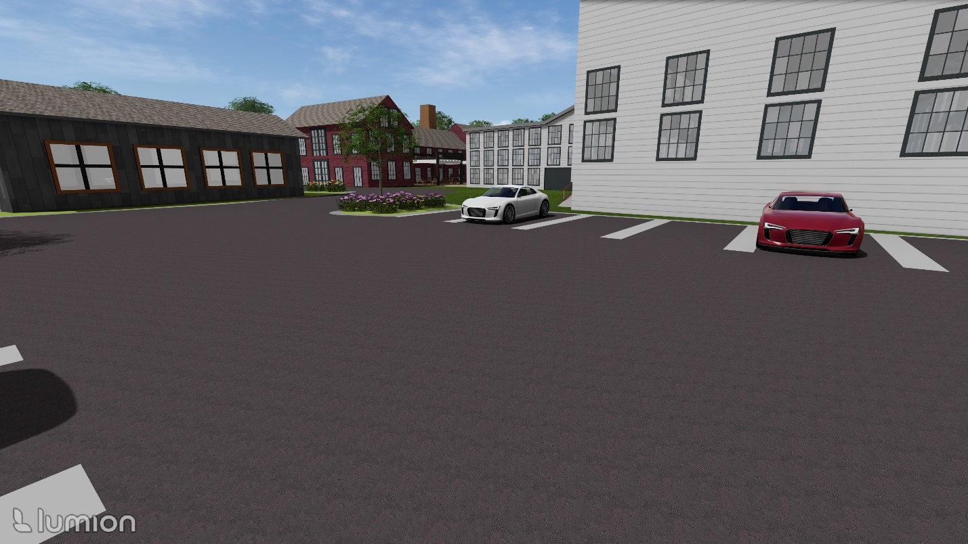
Figure 29. Scenario A: Ground View from 30 Mason St Building Parking Lot [Facing ~Southeast]

Scenario B: Mixed-Use Housing and Commercial with Connection to Main Street
The WeBuildUS plan proposed various commercial amenities for the Site, as well as 34 units of housing totaling 26,000 SF with 60 parking spaces totaling 30,000 SF of area including driveways, which would not be sufficient to meet Town zoning requirements. Coventry zoning regulations require 2 spaces per dwelling unit, as well as 1 space per 250 GFA for commercial and office space uses. The rendering for Scenario B includes 60 parking spaces, allowing for 22 dwelling units (Table 9). This would utilize ~10,000 SF and require ~1500 SF of vegetated area to fulfill the Coventry zoning requirement of 15% landscaped parking area. Seen in Table 10, excluding space for hallways and utilities, this could allow for the following sizes and quantity of residential units in each building:
- 30 Mason St Building: 19 Units
  - Nine 1,000 SF
  - Ten 1,400 SF
- 28 Mason: 3 Units
  - Three 1,000 SF
Table 9. Reuse Scenario B Parking Requirements
Use | Parking Requirement | Total GFA (or # Units) in Reuse Scenario | Total Required Parking
Residential | 2/dwelling unit | 22 Dwelling Units | 45
Commercial | 1/250 GFA | 1,700 SF GFA | 7
Office Space (Incl. Artists’ Studio) | 1/250 GFA | 2,000 SF GFA | 8
Totals: | - | 22 dwelling units + 3,700 SF GFA | 60
Table 10. Reuse Scenario B Unit Count Breakdown
 | 30 Mason |  |  | 28 Mason |  |  | Totals
 | SF/Unit | # Units | Total SF Available | SF/Unit | # Units | Total SF Available | Proposed Unit Count | Total SF Available
Ground Floor: | 1,000 | 4 | 4,000 |  |  |  | 4 | 4,000
Second Floor: | 1,400 | 10 | 14,000 | 1,000 | 3 | 3,000 | 13 | 17,000
Third Floor: | 1,000 | 5 | 5,000 | - | - | - | 5 | 5,000
Totals: |  | 19 | 23,000 |  | 3 | 3,000 | 22 | 26,000

Figures 30 to 39 show to-scale, 3-D renderings of Scenario B created using SketchUp Pro 2024 and Lumion Student.
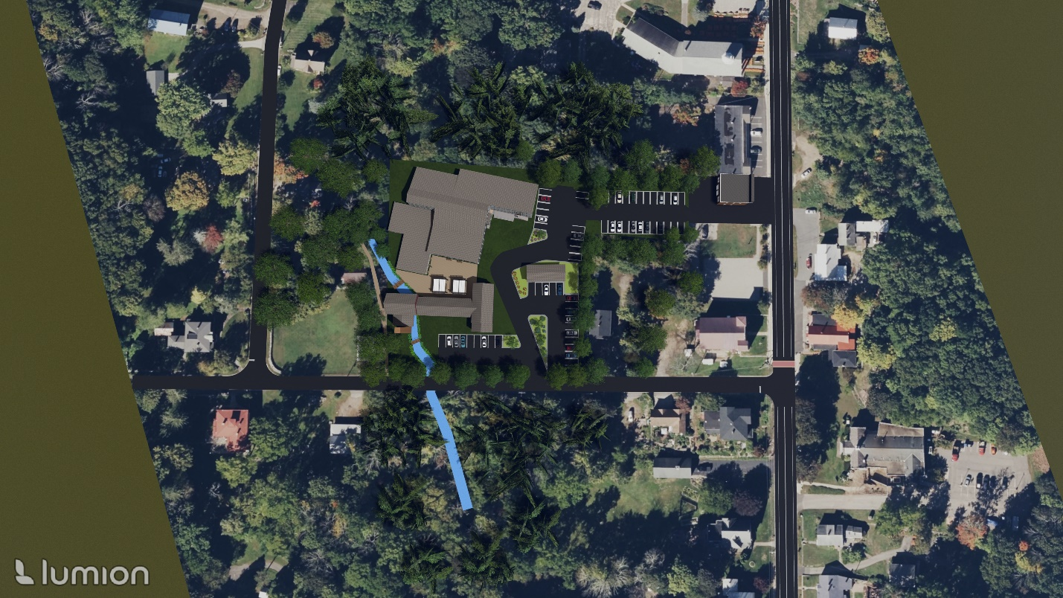
Figure 30. Scenario B: Birds’ Eye View
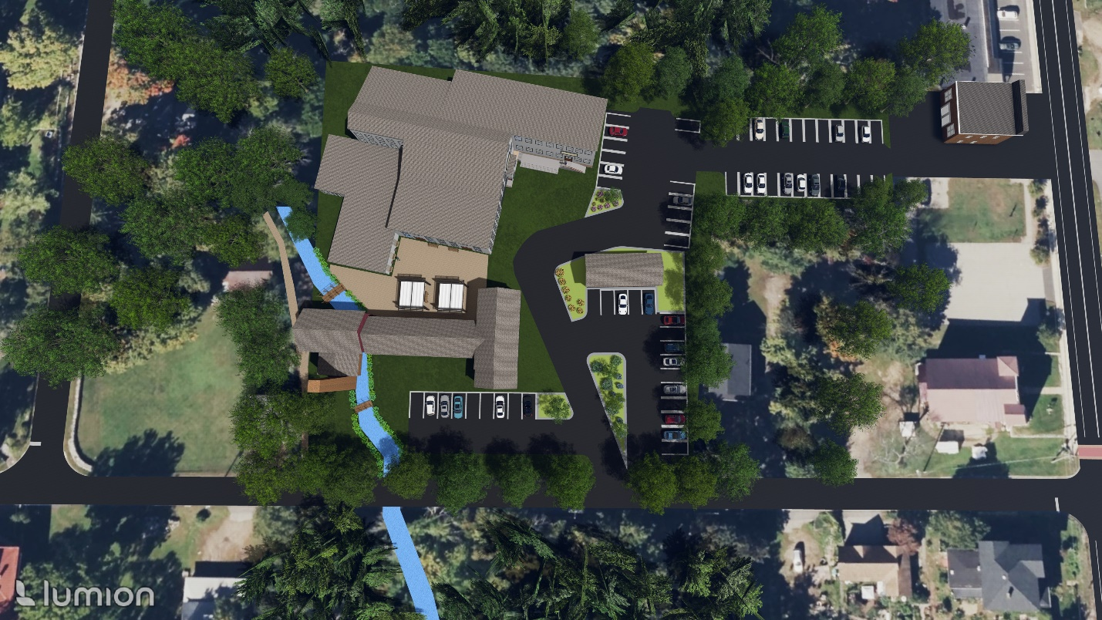
Figure 31. Scenario B: Zoomed-In Birds’ Eye View

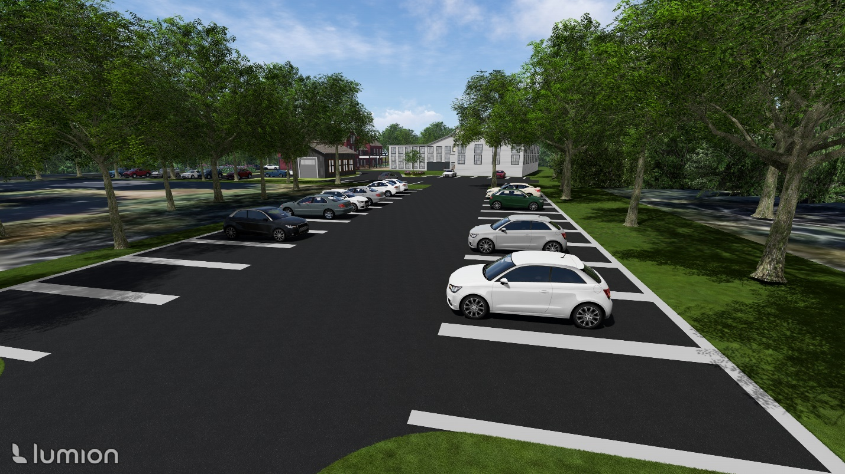
Figure 32. Scenario B: View of 1153 Main St Parking Lot [Facing South towards 28 and 30 Mason Buildings]
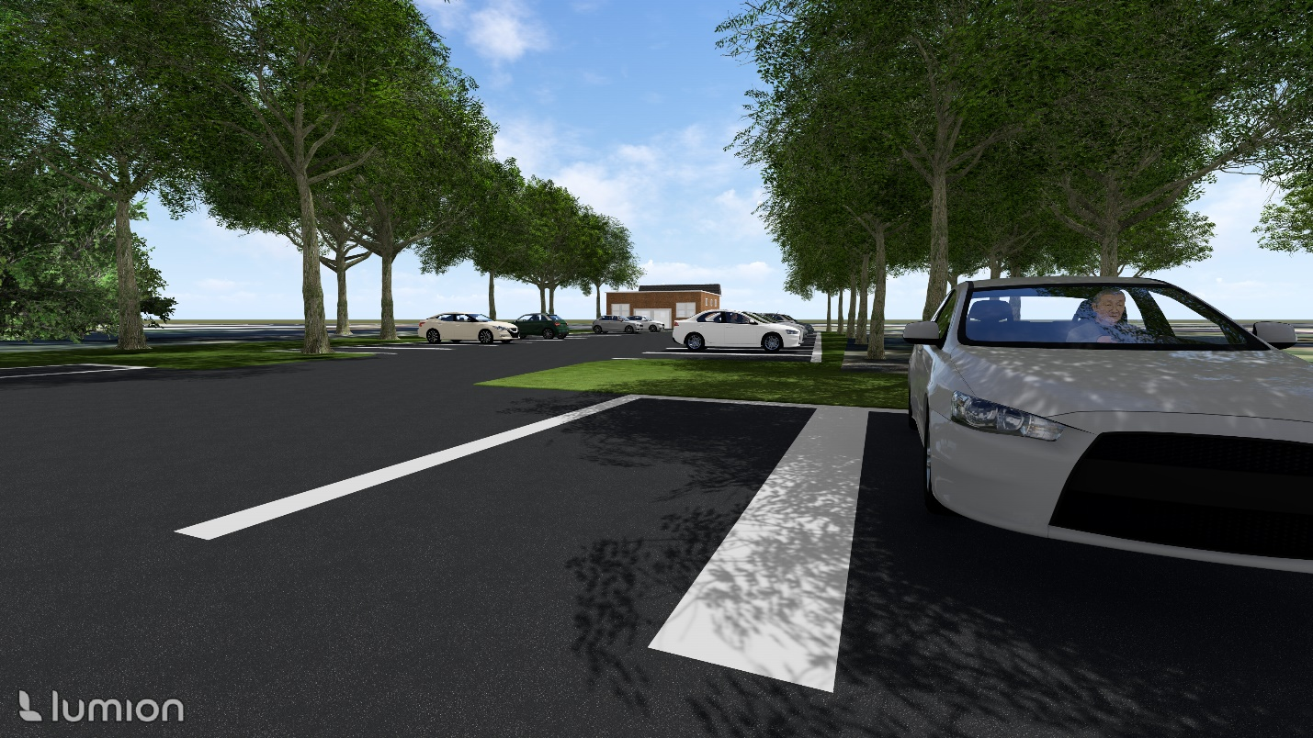
Figure 33. Scenario B: Alternative Top View of 1153 Main St Parking Lot [Facing North from 30 Main St Parking Area]

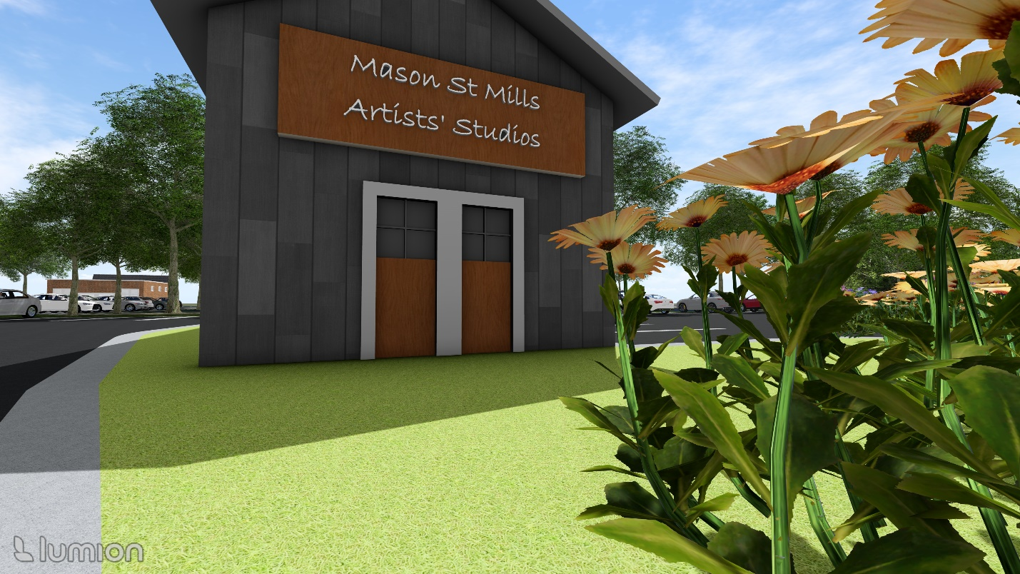
Figure 34. Scenario B: Ground View Facing 1153 Main St Parking Lot and Artists’ Studio Building [Facing ~North]
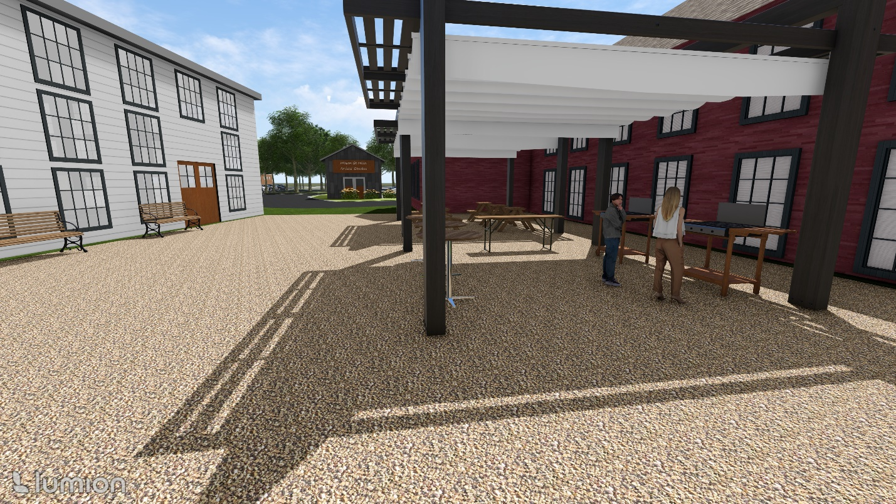
Figure 35. Scenario B: Ground View of Pavilion Area [Facing North Towards Artists’ Studio and Main St]

Scenario C: Mixed-Use Housing and Commercial with 1153 and 1159 Main St Parcels
The WeBuildUS plan proposed various commercial amenities for the Site, as well as 34 units of housing totaling 26,000 SF with 60 parking spaces totaling 30,000 SF of area including driveways, which would not be sufficient to meet Town zoning requirements. Coventry zoning regulations require 2 spaces per dwelling unit, as well as 1 space per 250 GFA for commercial and office space uses. The rendering for Scenario C includes 130 parking spaces, which would allow for 57 dwelling units (Table 11). Since it is unlikely that 57 units could fit within the 26,000 SF of available residential space in both buildings, it is proposed that 30 parking spaces be used for the Mill Brook Park/Trail and other uses nearby along Main St, leaving a remainder of 85 parking spaces that could accommodate 42 dwelling units. This parking area would utilize ~21,060 SF, excluding aisles, and require ~3,100 SF of vegetated area to fulfill the Coventry zoning requirement of 15% landscaped parking area. Seen in Table 12, excluding space for hallways and utilities, this could allow for the following sizes and quantity of residential units in each building:
- 30 Mason St Building: 37 Units
  - Three ~1,300 SF
  - Twenty-Four ~580 SF
  - Ten 500 SF
- 28 Mason: 5 Units
  - Five 600 SF
Table 11. Reuse Scenario C Parking Requirements
Use | Parking Requirement | Total GFA (or # Units) in Reuse Scenario | Total Required Parking
Residential | 2/dwelling unit | 42 Dwelling Units | 85
Commercial | 1/250 GFA | 1,700 SF GFA | 7
Office Space (inc. Artists’ Studio) | 1/250 GFA | 2,000 SF GFA | 8
Supplementary Parking (Mill Brook Park/Trail; Other Nearby Uses Along Main St) | N/A | N/A | 30
Totals: | - | 42 dwelling units + 3,700 SF GFA | 130
Table 12. Reuse Scenario C Unit Count Breakdown
 | 30 Mason |  |  | 28 Mason |  |  | Totals
 | SF/Unit | # Units | Total SF Available | SF/Unit | # Units | Total SF Available | Proposed Unit Count | Total SF Available
Ground Floor: | ~1300 | 3 | 4,000 |  |  |  | 3 | 4,000
Second Floor: | ~580 | 24 | 14,000 | 600 | 5 | 3,000 | 29 | 17,000
Third Floor: | 500 | 10 | 5,000 | - | - | - | 10 | 5,000
Totals: |  | 37 | 23,000 |  | 5 | 3,000 | 42 | 26,000

Figures 36 to 42 show to-scale, 3-D renderings of Scenario C created using SketchUp Pro 2024 and Lumion Student.
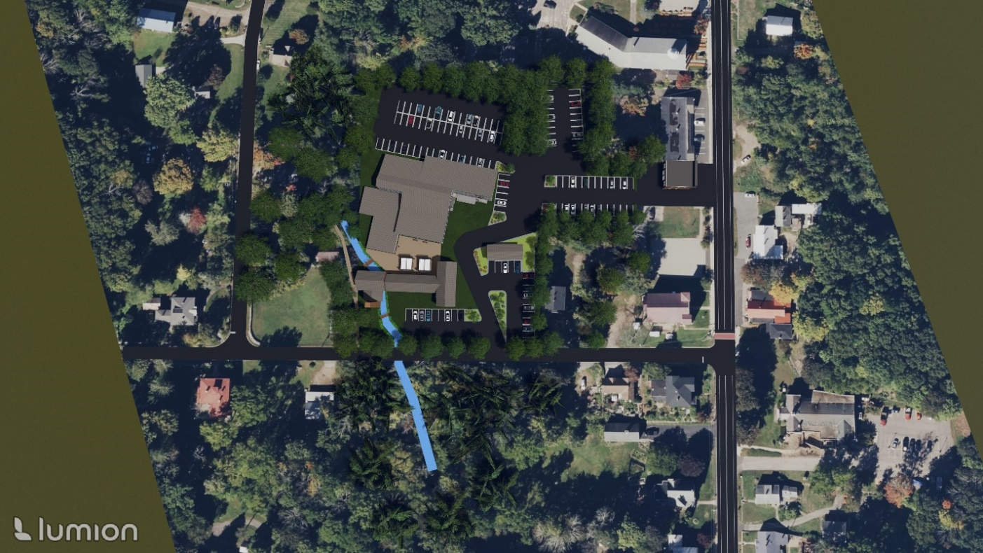
Figure 36. Scenario C: Birds’ Eye View

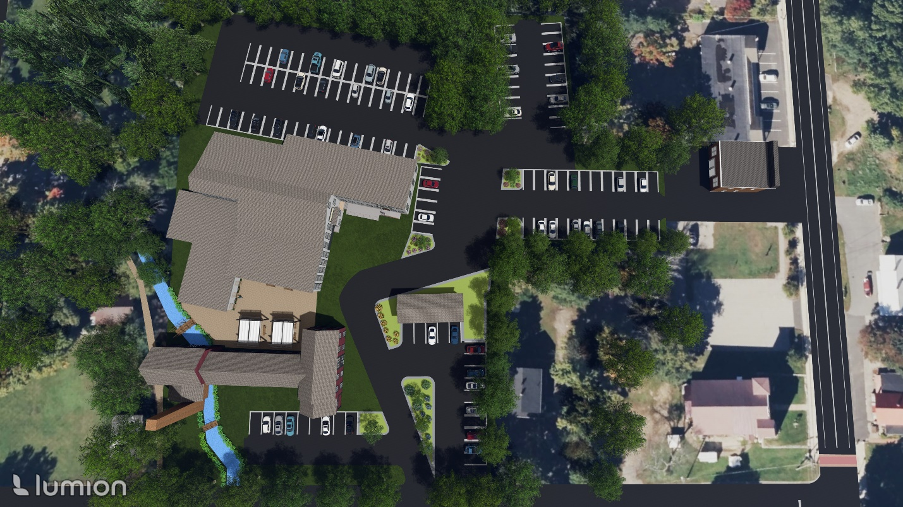
Figure 37. Scenario C: Zoomed-In Birds’ Eye View

Figure 38. Scenario C: Ground View from 1153 Main St Parking Lot Entrance [Facing ~South]
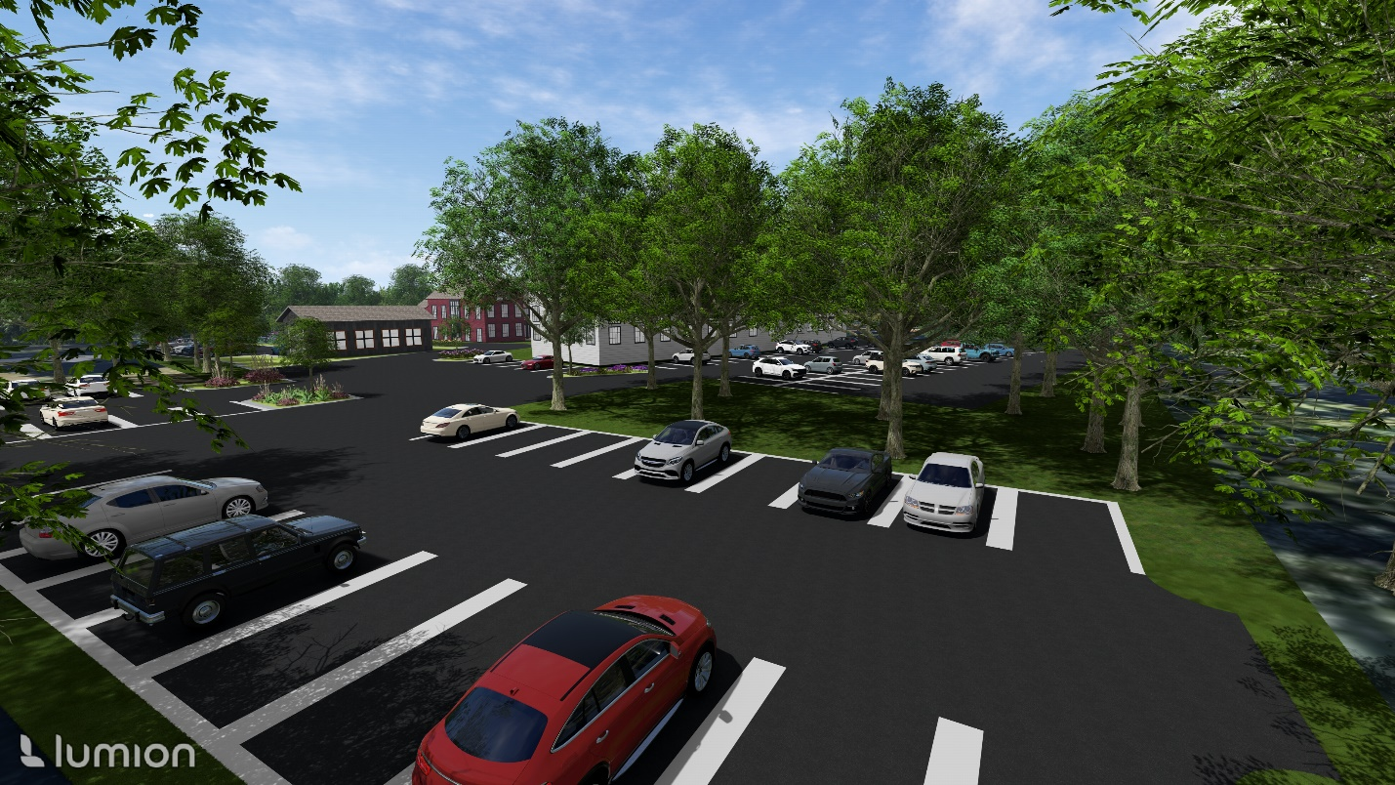
Figure 39. Scenario C: View from Rear of 1159 Main St Parking Area [Facing ~Southwest]

Figure 40. Scenario C: View of Artists’ Studio and Northern Corner of 30 Mason St. Building [Facing ~Northwest Towards 1153 and 1159 Main St Parking Areas]
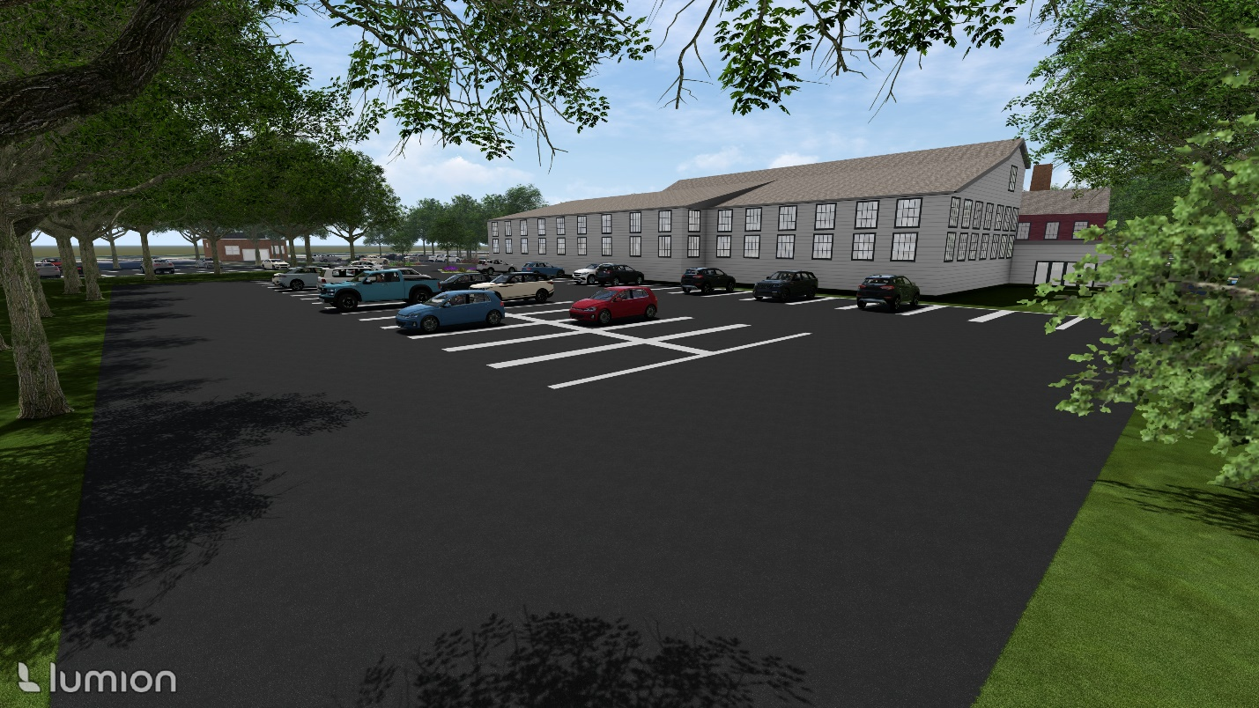
Figure 41. Scenario C: Ground view from Rear of Larger 1159 Main St Parking Area [Facing ~Southwest]
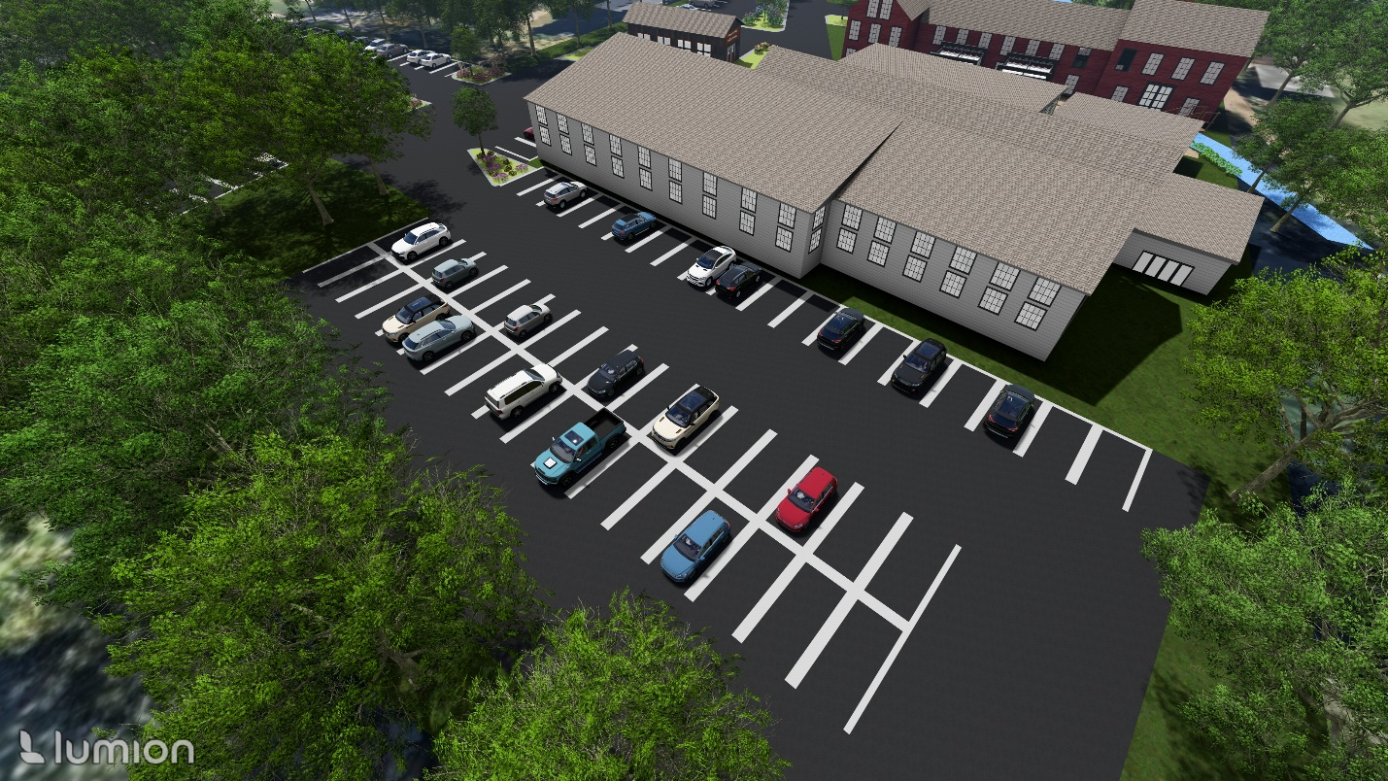
Figure 42. Scenario C. Top view of Larger 1159 Main St Parking Area [Facing ~Southwest]

Scenario D: Buildings are Removed, Open Space Available
No rendering is associated with Reuse Scenario D. Any new development at the Site cannot exceed ~68,000 sf, pursuant to the Coventry zoning limit of 90% lot coverage for impervious surfaces. Impervious surfaces include any paved areas (aisles, parking lots) in addition to building footprints. Table 13 illustrates potential building footprint and parking combinations that would adhere to this limit, assuming two-story buildings with some combination of residential and/or commercial uses on the first and second floors, although these are not representative of every possible site layout. Since the Site abuts Mill Brook Park, there is also potential for the ample open space at the Site to be used for supplementary parking for the Mill Brook Park/Trail if the buildings are removed. Unlike Reuse Scenarios A B, or C, Scenario D may present few or no issues with certain site-specific considerations, including zoning, floodplains, wetlands, water supply, and wastewater disposal.
Table 13. Reuse Scenario D Potential Site Layouts
 | Total Building Footprint (SF) | Total 1,000-SF Residential Dwelling Units | Total Commercial Space (GFA in SF) | Total Parking Spaces Required
Option 1: Balanced Mixed-Use | 30,000 SF | 30  (30,000 SF) | 30,000 SF | 60 (Res.) + 120 (Comm.) = 180
Option 2: Residential-Dominant Mixed-Use | 30,000 SF | 45  (45,000 SF) | 15,000 SF | 90 (Res.) + 61 (Comm.) = 151
Option 3: Commercial-Dominant Mixed-Use | 30,000 SF | 15  (15,000 SF) | 45,000 SF | 30 (Res.) + 180 (Comm.) = 210

REFERENCES
“Addison Kingsbury Box Printing Factory.” Making Places, 13 Aug. 2015,
https://connecticutmills.org/find/details/addison-kingsbury-box-printing-factory.
“Business Data.” CTData Collaborative, https://www.ctdata.org/business.
“Census Data Tables.” U.S. Census Bureau, https://data.census.gov/.
“Climate and Economic Justice Screening Tool (CEJST).” Executive Office of the President of the United
States Council on Environmental Quality, https://screeningtool.geoplatform.gov/en/#3.55/32.64/-100.38.
“Climate Explorer.” U.S. Climate Resilience Toolkit, https://crt-climate-explorer.nemac.org/.
“Connecticut Broadband Availability Map.” Connecticut Office of Policy and Management, Dec 2023,
https://broadbandmaps.ct.gov/apps/550540f2e428412a9ad0f789d5bd5724/explore.
“Coventry Public Schools.” Coventry Public Schools, https://www.coventrypublicschools.org/.
“Design Guidelines for Commercial Development.” Town of Coventry CT, 12 Oct. 2010,
https://www.coventry-ct.gov/DocumentCenter/View/155/Coventry_Commercial_Design_Guidelines_10_12_10?bidId=
“Distressed Municipalities.” Connecticut Department of Economic and Community Development (CT
DECD), https://portal.ct.gov/decd/content/about_decd/research-and-publications/02_review_publications/distressed-municipalities.
“EJ Screen Mapper (Version 2.3).” U.S. EPA, https://ejscreen.epa.gov/mapper/.
“Food Access Research Atlas.” USDA Economic Research Service,
https://www.ers.usda.gov/data-products/food-access-research-atlas/go-to-the-atlas/.
“Historic Coventry Village.” Town of Coventry CT,
https://www.coventry-ct.gov/556/Historic-Coventry-Village.
“Housing Affordability Plan.” Town of Coventry CT, May 2022,
https://www.coventry-ct.gov/DocumentCenter/View/6556/Appendix-B-Needs_Assessment-Final#:~:text=In%20Coventry%2C%20Area%20and%20State%20Median%20Income%20limits%20are%20the%20same.&text=A%20family%20of%204%20making,low%2Dincome%20based%20on%20AMI.&text=Housing%20costs%20include%20rent%20or,HOA%20fees%2C%20and%20maintenance%20costs.
“Hydrologic Soil Group – State of Connecticut.” USDA,
https://portal.ct.gov/-/media/CSC/3_Petitions-medialibrary/Petitions_MediaLibrary/MediaPetitionNos1501-1600/PE1541/PETITIONERSUBMISSIONS/PETITION/Figure-11---NRCS-Map_Hydrologic_Soil_Group.pdf.
“National Risk Index.” FEMA, https://hazards.fema.gov/nri/map.
“National Silk Co. Inc.” Making Places, 13 Aug. 2015,
https://connecticutmills.org/find/details/national-silk-co.-inc.
“Plan of Conservation and Development.” Town of Coventry CT, July 2020,
https://www.coventry-ct.gov/DocumentCenter/View/4221/FINAL-JULY-1-2020-POCD.
“Population Estimate, Total (5-Year Estimate) in Tolland County, CT.” St. Louis FRED,
https://fred.stlouisfed.org/series/B03002001E009013.
“Soil Survey of State of Connecticut.” USDA, 2003, https://cteco.uconn.edu/docs/usda/connecticut.pdf.
“TopoView.” United States Geological Survey (USGS),
https://ngmdb.usgs.gov/topoview/viewer/#4/40.00/-100.00.
“Town of Coventry GIS & Real Property Information.” Mapxpress, http://coventry.mapxpress.net/.
“Water Quality Classifications Coventry, CT.” CT DEEP, Oct. 2018,
http://cteco.uconn.edu/maps/town/wtrqualcl/WtrQualCl_Coventry.pdf.
“Web Soil Survey.” (USDA), https://websoilsurvey.nrcs.usda.gov/app/.
“Zoning Regulations.” Town of Coventry CT, 16 Dec. 2023,
https://www.coventry-ct.gov/DocumentCenter/View/8292/FINAL-12-16-23-ZONING-REGULATIONS.

APPENDICES
Appendix A. Map of Coventry within the State of Connecticut

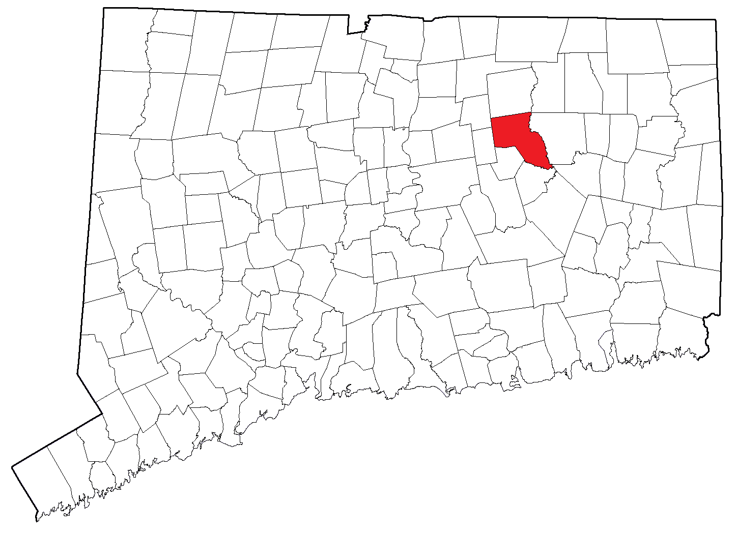

Appendix B. Web Soil Survey Map (Source: USDA)
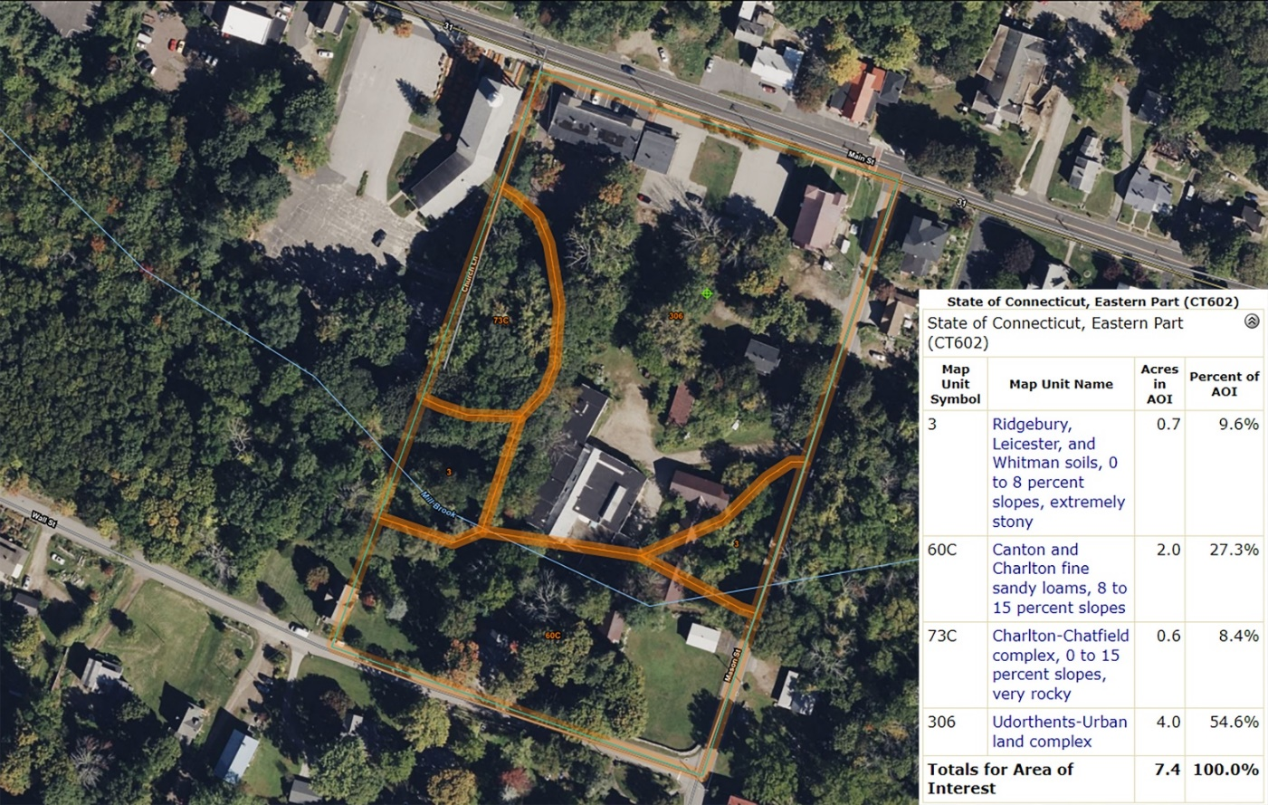

Appendix C. Topographic Map of the Town of Coventry and Surrounding Area (Source: USGS USTopo)
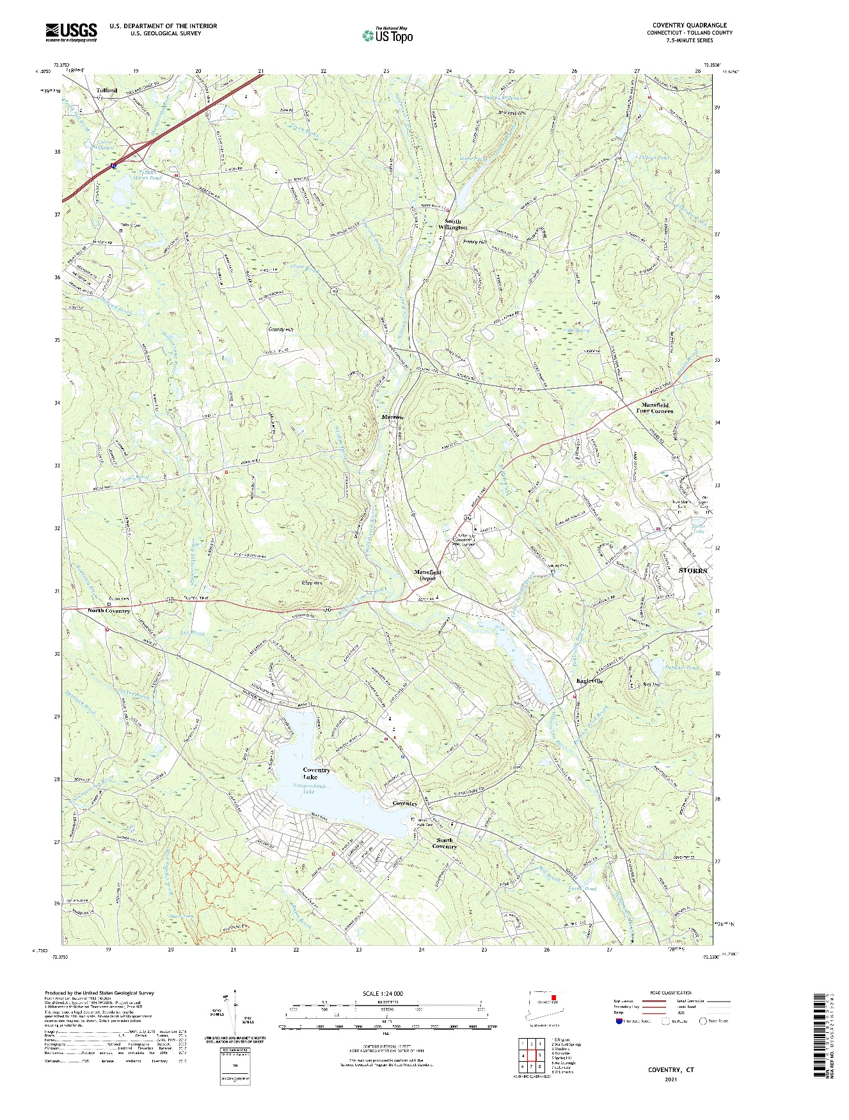

Appendix D. Groundwater Classification Map of the Town of Coventry and Surrounding Area (Source: CT DEEP)
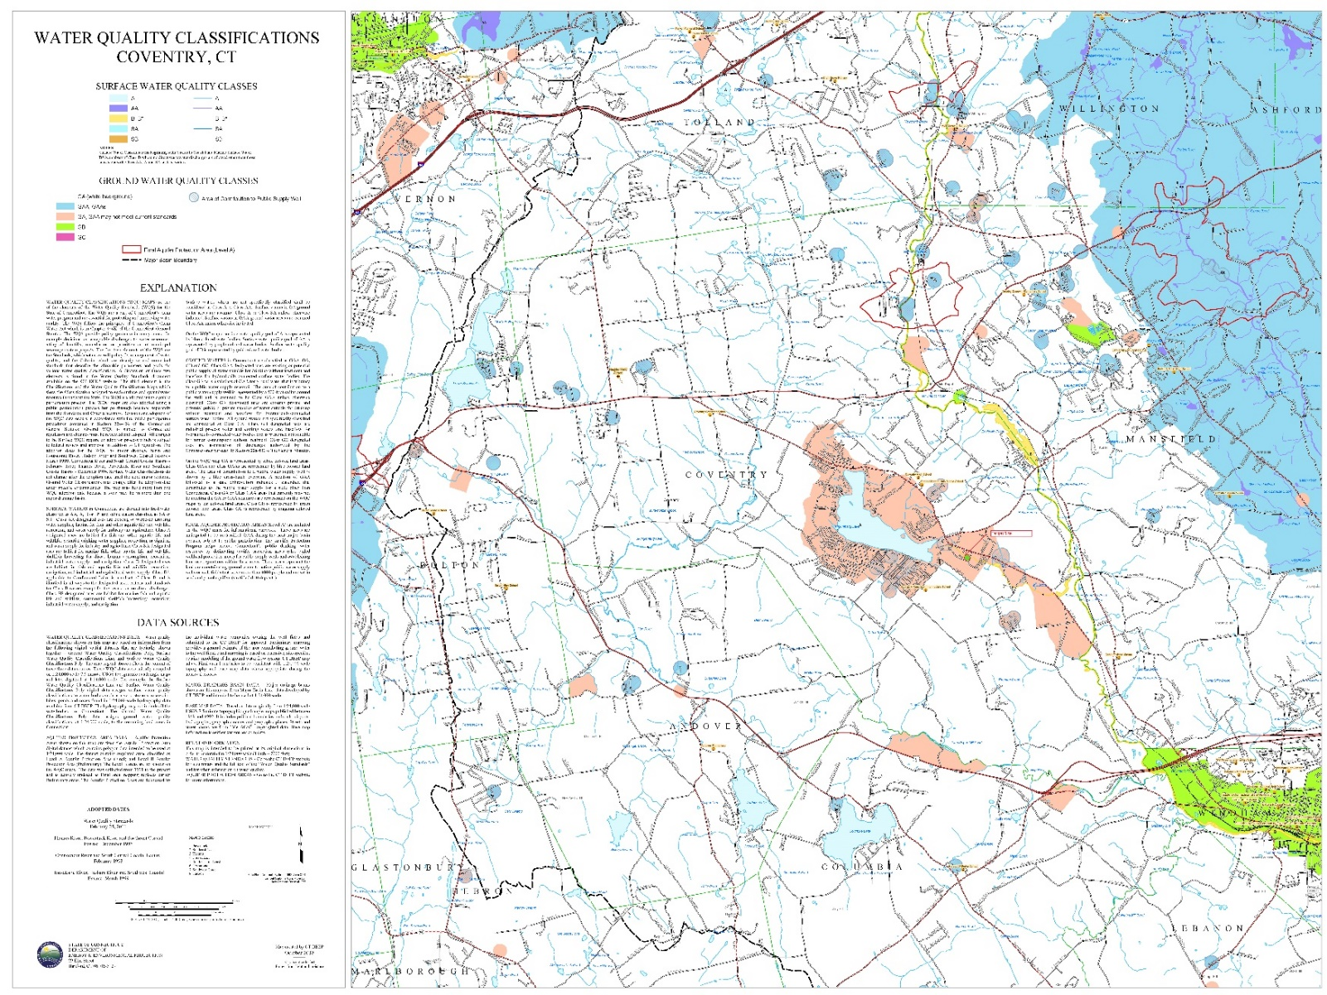
Appendix E. Map of Coventry Bike Trail System [Site Marked by Green Arrow] (Source: Town of Coventry)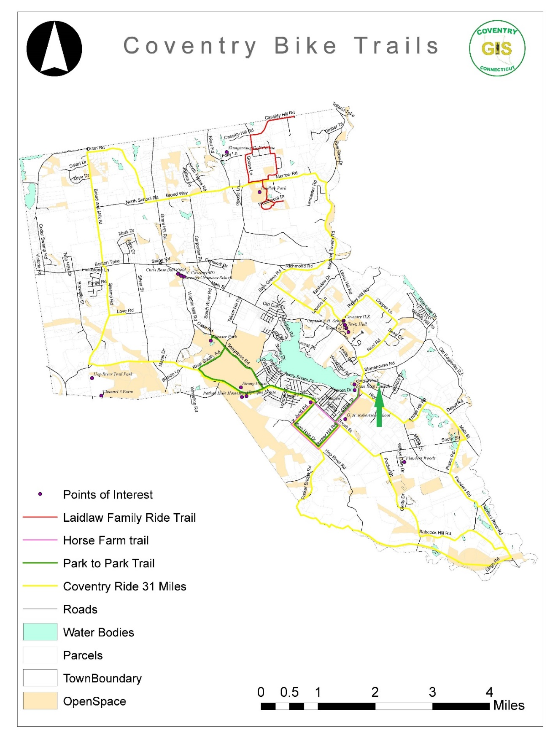

Appendix F. VC District Parking Requirements (Source: Town of Coventry Zoning Regulations)

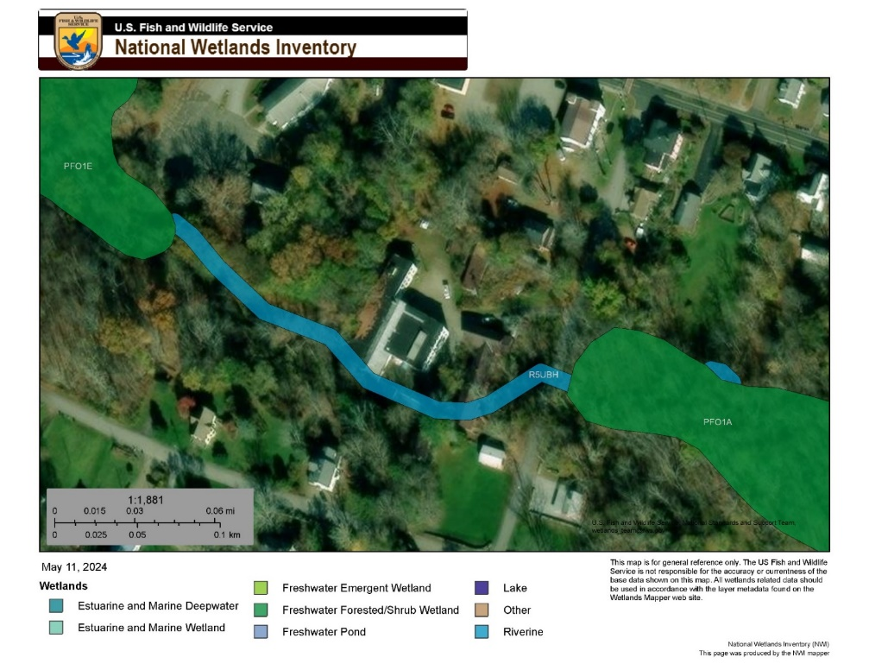
Appendix G. National Wetlands Inventory Map (Source: USFWS)

“Higher” and “Lower” emissions Scenarios are based on Representative Concentration Pathways (RCPs). RCPs are an important tool to understanding the future impacts of climate change on varying areas of the planet. RCPs are comprehensive datasets that combine historical and contemporary environmental trends (e.g., CO2 emissions, weather and temperature patterns) to predict the impacts of climate change based on different possible Scenarios through 2300. RCP2.6 is the lowest emission Scenario, where greenhouse gas emissions become ‘very low’ – this is used in Figure as the “lower emissions” Scenario. RCP 8.5 is used for the “higher emissions” Scenario, where greenhouse gas emissions continue at an increasing rate and the effects of climate change are more pronounced. “The Representative Concentration Pathway: An Overview” by Van Vuuren, et al., includes more information on RCPs.

