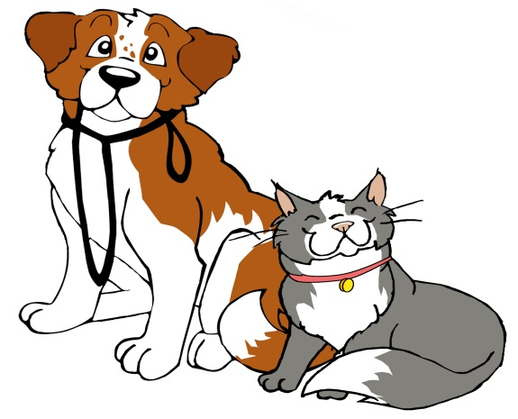
Rabies Clinic

Sponsored By: The Town of Coventry in cooperation with the Connecticut Veterinary Medical Association

SATURDAY, May 4, 2024
10:00 AM – 12:00 PM
CAPT. NATHAN HALE SCHOOL
1776 MAIN STREET
COVENTRY

DOGS MUST BE ON LEASHES • CATS MUST BE IN CARRIERS
If previously vaccinated for Rabies, bring written proof.

COST IS $20.00 CASH ONLY PER ANIMAL
Individuals presenting their identification cards for state assistance programs will be given ONE FREE vaccination for their own animal.

CONNECTICUT LAW REQUIRES ALL CATS AND DOGS OVER 3 MONTHS OF AGE TO BE VACCINATED AGAINST RABIES AND DOGS OVER 6 MONTHS OF AGE TO BE LICENSED

