Trails/Open Space Reporting Form
Use this form to report an issue on one of Town of Coventry’s open space properties

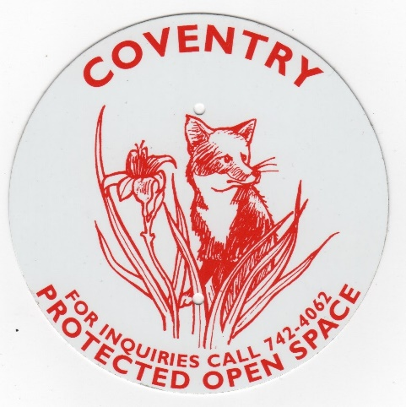

- Name of Town Property (Click on one box)
Choose an item.
- Date of your observation (mm/dd/yyyy)
Click or tap to enter a date.
- Please describe the issue (i.e. trail erosion, tree fall/safety, overgrown vegetation, degraded structure, vandalism)
Click or tap here to enter text.
- Please describe where on the property we can find the issue (e.g. lat/long, GPS coordinates, or descriptive text).
Click or tap here to enter text.
- Please include your email address and/or phone number (optional) so we can follow up with any additional questions
Click or tap here to enter text.
- For information about the Protected Spaces Stewardship Committee, check out our town webpage.

/v 03.2026

